Hammersmith & Fulham Cyclists
Special Bike Week Newsletter June 2002 - www.hfcyclists.org.uk
London Cycling Campaign - local co-ordinator John Griffiths 020 7371 1290 john@truefeelings.com

New Free Cycle Maps

TfL and the London Cycling Campaign have co-operated to produce these maps. They are based on the A to Z of London and really useful. We now have supplies of local maps, which you can pick up at our events.

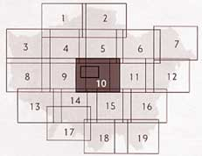
Or order directly for FREE from LCC [www.lcc.org.uk] or
TfL on (020) 7222 1234.
Map 9 covers H&F and more, map 10 covers central London, map 14 covers Richmond Park and Wimbledon Common
[Max the dog was a star on TV at Ken’s launch of the maps]

Shepherds Bush Green

At our last meeting Mike Gilroy from the Council’s Highways dept showed us the latest plans. We discussed improvements that we hope will be incorporated. It was a very satisfactory meeting. We hope soon to be involved in talks concerning the roundabout.

The tram will affect things if it comes to be. Work on the NW corner may be delayed until plans are more settled.

A Printer and Posters

We now have a colour printer, as you can see, thanks to a grant from LBHF Education Dept. Jane Knight has designed a luscious poster. We have laminated prints for you to put in a friendly place.
Our Bike Week Events

SUNDAY 16 JUNE Ride to Richmond Park and Wimbledon Common. Join us and meet local cyclists. Suitable for all the family - bring a picnic. Meet 11am beside the river, Furnival Gardens, Hammersmith W6

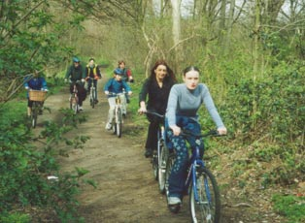

WEDNESDAY 19 JUNE
Enjoy a free breakfast laid on by H&F Council. Meet nice and significant people. 8-10am H&F Town Hall forecourt, King St.
Simon Franklin: 020 8753 3353

SUNDAY 23 JUNE
Ride to Camden Bloomsbury Bikefest. Meet 12.30pm at the café inside Holland Park, before setting off at 1pm for a gentle ride, largely through parks.

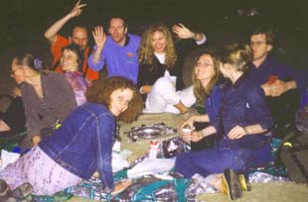

SUNDAY 23 JUNE Barbecue and picnic on the beach. Enjoy the most peaceful place in London. Bring food and suitable refreshment and something to lie on. From 5pm till late on the beach, down steps in front of the Royal Festival Hall.

[contact co-ordinator or see website for details of events]

Parking at sports centres

We are involved with a grant application for secure cycle parking at the Council’s sports centres. It may involve cages.

Don’t Choke London

10 - 14 June. LBHF’s Alex Forrest is organising. Something will take place each day in Lyric Square.
We will have a stand on Friday 14th. If you can help on the day please do so.

Roger’s barbecue

Roger de Freitas will host an evening Garden Party / Barbecue on Wednesday 17 July. Contact John or see website for details.

LCC

You do not need to be a member of the LCC to be involved in our activities. However we suggest you join for the many benefits.
Phone 020 7928 7220
Visit www.lcc.org.uk

hfcyclists - join egroup

Our meetings are on the second Wednesdays of the month, with some wine served. Next meetings, 12 June and 10 July at 7.30pm.
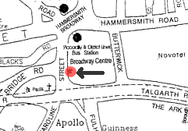
In the Info Centre, 20 Broadway Shopping Centre, in an external courtyard on the West side.

Be part of our community. Our egroup details are on our website.
john g

