hfcyclists
London Cycling Campaign / Dec 2002
Local co-ordinator John Griffiths
john@truefeelings.com 020 7371 1290
www.hfcyclists.org.uk

Conflict

One of the big issues at the moment is the conflict between pedestrians and cyclists.

Hammersmith Bridge

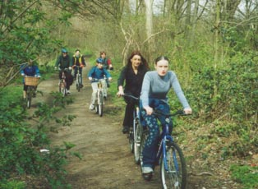
The police are starting to clamp down on cyclists riding on the footways over the bridge. Signs say cyclists have to dismount. 11 year-olds are allowed to cycle on the pavement. People are questioning whether adults should be allowed to cycle with children. The roadway over the bridge is very daunting. The width of the road narrows at the pinch points. We would like to see the Council make changes to the roadway to make it a safe place for all to cycle.

Riverside Malls

There are different thoughts on cycling in this area. Shared use, dismount when busy, no cycling. It is a delightful area in which to cycle. Resident and pedestrian pressure is against cyclists. What ever you do, please cycle carefully and give priority to pedestrians. Soon, perhaps by March 2003, a cycle path will be put along the A4. If speed is your priority please use this to by-pass the riverside.

Hammersmith Broadway

The Council is spending £150K on an East - West pavement route that uses the pedestrian subway under Fulham Palace Road as a temporary link. This

will be a dismount section. However conflict with pedestrians is going to be inevitable at peak times. This may give some extra impetus to the planned study of surface level crossings. On the roadway advanced stop lines are being put in around the gyratory. We would like to see a more aggressive attitude in giving roadspace to cyclists. There are rumours of possible changes to the bus station. This would give an opportunity for a major rethink.

Festive ride

There’s a ride on Sunday 15th December to a pub in Barnes, bringing together people from cycling groups across West London. Leaves Furnival Gdns at 11am. For more details see the website or call co-ordinator.

hfcyclists - website

Find out about the issues and conflicts affecting cyclists in H&F. Visit our website.

hfcyclists - join egroup

Keep up to date with the latest news and events. The email group continues to be a lively discussion forum about the joys and perils of cycling in H&F. Join from website.

Next Meeting
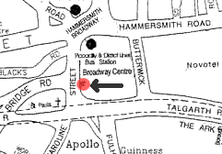
Our meetings are on the first Tuesday of the month. The next meetings will be on 3 December and 7 January 2003 at 7.30pm in the Info Centre, on the main Hammersmith Broadway traffic island. (20m northwest of the Old Trout pub). Wine and refreshments provided.

We would like more members to better represent the cycling community, so please come along and get involved! Whether your strengths lie in lobbying the council, web design, motivating people, traffic planning, art or promoting events, or if you just want to meet people and do your bit to create a more sustainable part of London, everyone is welcome.

London Cycling Campaign

You do not need to be a member of the LCC to be involved in our activities. However we suggest you join for the many benefits, rides, discounts, insurance, magazine

Phone 020 7928 7220
or visit www.lcc.org.uk

Sarah Shubinsky
and John Griffiths

