Hammersmith & Fulham Cyclists
Newsletter April 2002 - www.hfcyclists.org.uk
London Cycling Campaign - local co-ordinator John Griffiths 020 7371 1290 john@truefeelings.com

Shepherds Bush Green

It is now crunch time for Shepherds Bush Green. In May 2002 the big works begin.

We have been involved in discussions for nearly a year now on how cycling will be incorporated into the new “improved” Green. To no great effect it would seem.

An engineer involved with the planning has left. Consultants on the scheme appear to be less involved. Joint meetings with those involved in cycling such as TfL and the Cycling Centre of Excellence have not materialised.

The problem

The architects [Ian Ritchie] for Chelsfield’s WhiteCity scheme are helping the Council by coming up with plans for a new Shepherds Bush Green. This involves widening the pavements [ie narrowing the roadway] on the west and south sides of the Green.

They are not keen to have cyclists on the Holland Park roundabout. However this roundabout lies on the desire line for a Strategic Priority Route which the London Cycle Network is now concentrating on. The roundabout is under the control of TfL which involves a degree of co-operation in planning.
Cyclists want to use the roundabout and provision should be made for our safety.

A big problem is the area in front of the new West12 Centre on the south side of the Green. Here buses are crossing the flow of traffic to get to bus stops. Traffic wants to turn left into

Rockley rd. Cyclists want to go straight on or cross to the Green. The present plans leave cyclists to fend for themselves in this area.

In a few years time a new bus station next to the Central line station [the Southern Interchange] will create more difficulties as buses cross to the bus stops on the south.

At the Goldhawk rd junction the right turn for cyclists from Goldhawk rd has been removed. From the cycle tracks on the Green you cannot go south onto Shepherds Bush rd. [see inset -Goldhawk rd on left, Shep Bush rd at bottom].

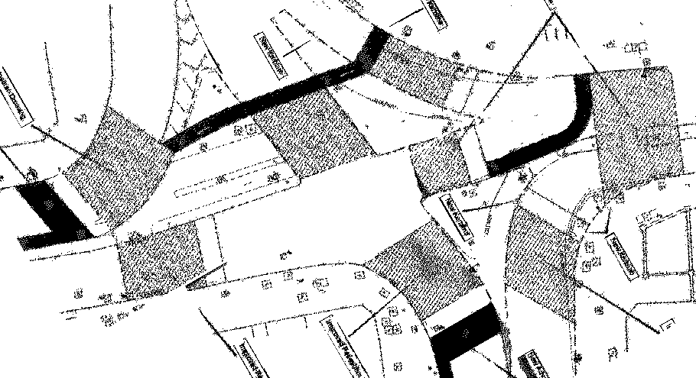
At the Uxbridge rd / Wood Lane junction it does not look as if the reservoirs on the islands will cater for the expected numbers of cyclists.

A solution - be involved

Please be involved. In the next month or so these plans can be changed. Nobody, including the Council, wants a disaster. The Green could be a flagship for cycling design and excellence. Bring your ideas and support now. See our website for more details.

Please try and come to our next meetings, on 2nd Wednesdays of month, April 10th and May 8th at 7.30pm. In the Info Centre, Broadway Shopping Centre, in an external courtyard on the West side. It faces St Paul's Church.

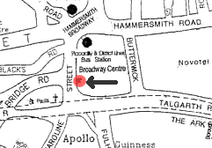
Please contact me if you want to be involved but cannot come along.

Rides, activities, campaigns, email group

For more info, or to join our active email group, visit our web site. John Griffiths

