OBSERVATIONS ON THE STEPS / RAMPS AT HUNT CLOSE BY HFCYCLISTS
5 SEPTEMBER 2009

Observations written by John Griffiths following a site visit to the steps / ramp at Hunt Close leading to the bridge to Westfield. The top part of the ramp is sealed off so full access was not available. These are the views of hfcyclists and not necessarily those of any LBHF officer.

This site visit followed LBHF’s initial statement that officers would only carry out any investigations here after the crossing facilities were opened.

PRESENT:
Chris Bainbridge [LBHF]
John Griffiths [Chair hfcyclists /LCC]
Sharon Norris [Secretary hfcyclists]
Colin Murphy [hfcyclists]
Angela Varland, [Chair Edward Woods Estate TRA - wheeled zimmer user]
Doreen Bubb [motorised wheel chair user]
[the 2 above present through Jacqueline Boyce, of Edward Woods Community centre]

The following appeared when they saw us there, and we discussed concerns with them.
Mrs Pranee Scott, [ local resident, residence bordering on the ramp]
Tracey, [local resident]
Amanda Tatham, [vice chair Hunts Close Association]

POSSIBLE CRITICAL DESIGN PROBLEM

There is a major problem in the design of this shared pedestrian /cycle route. The top section of the ramp leading to the crossing is a narrow alleyway. Those crossing may have wheelchairs, cycles or pushchairs or have heavy shopping. Some will be slow or infirm. At peak times people in the alleyway still waiting to cross may impede the arrival of those crossing from Westfield. Those crossing from Westfield at the rear may be left exposed on the highway when the lights change.

This layout can be seen in the satellite view taken from Multimap. This shows the H – bridge giving access to Westfield from the A3220. On the right hand side is the ramp [d f g h i j k] with sharp bends at [f and h]. Steps [ e – j] cut across the ramp. The roadway at the bottom of the ramp is Hunt Close [LBHF].

Pedestrians and cyclists leaving Westfield from the Eastern Access road access the higher level of the H-bridge via lifts or wide steps. They then cross [a to b] the northbound traffic stream entering Westfield.

They then cross [c to d] the southbound traffic stream leaving Westfield to arrive at the top section of the very narrow ramp [d to f].

Now there will also be people at the head of the ramp waiting to cross to Westfield. People waiting to cross may be backed up in this alleyway. If the people waiting to cross cannot get away before those coming from Westfield arrive there will be restricted flow rates or a jam. Anyone left in the carriageway when the lights change will be in danger.

The problem also arises if the flow from Westfield exceeds the rate at which people can get into the alleyway. Note that this is also specified as a cycle route.

The width of the crossing appears to be less than 2.5m. and the width of the ramp between [d] and [f] less than 2m.

OTHER PROBLEMS WITH THE DESIGN

The top corner [f] of the ramp is very sharp. With vegetation vision is also restricted. [A mirror may help here, as well as trimming]

Just below this a retaining wall [g] juts out and restricts the width of the ramp.

At the next bend [h] the central railings unnecessarily make the corner harder to get around. These could be brought back a little.

Where the ramp [k] meets the pavement there is a slight difference in level annoying to those with a wheeled zimmer.

For those using the steps there are handrails for the upper flights. However there are no handrails for those using the bottom steps and going straight ahead [j].

CYCLISTS

There is concern that cyclists on the ramp will be crossing pedestrians on the stepped route. Signs should clearly say pedestrian priority.

The ramp is much narrower and the bends much sharper than is desirable for safe cycling. The ramp just ends on the footway with no obvious link to the carriageway.

The ramps are not suitable for segregated cycle lanes as
a] the widths are not wide enough to allow it
b] shared use with Pedestrian priority is preferred

We observed a cyclist carrying his bike up, and another cyclist cycling straight down the steps.

CONCERNS OF LOCAL RESIDENTS

Local residents raised concerns about
Insufficient lighting, and the possibility of being mugged here.
Need for CCTV cameras.
People climbing into their property via the missing trellis at [f]
Lack of bins for litter.

RESTORING THE PRESENT DAMAGE

There area has fallen into a poor state, and just restoring it to how it was meant to be may take a while.

Buddleia is growing through the paving at the point at the top where the path has been closed. The handrail has come away in places, and it appears that some components are missing. Covers for a gulley are missing. Vegetation needs to be cut back to clear the passage and increase visibility at corners.

CONTACT DETAILS

John Griffiths 020 7371 1290 / 07789 095 748 john@truefeelings.com
Sharon Norris 07977 092 070 sharonnorris1504@yahoo.co.uk
Colin Murphy 020 3188 3067 / 07760 237 337 hfcyclist@spudulike.me.uk
Chris Bainbridge 020 8753 3354 chris.bainbridge@lbhf.gov.uk
Angela Varland, Chair, Edward Woods estate TRA 020 7602 1806
Doreen Bubb 39 Norland House, 020 7603 8693
Mrs Pranee Scott, residence bordering on the ramp, 07956 469 694
Tracey, local resident, 07518 082 529
Amanda Tatham, vice chair Hunts Close Association, 020 7221 5530
Jacqueline Boyce, Edward Woods Estate Community Centre Manager, 020 7603 2324
SATELLITE VIEW

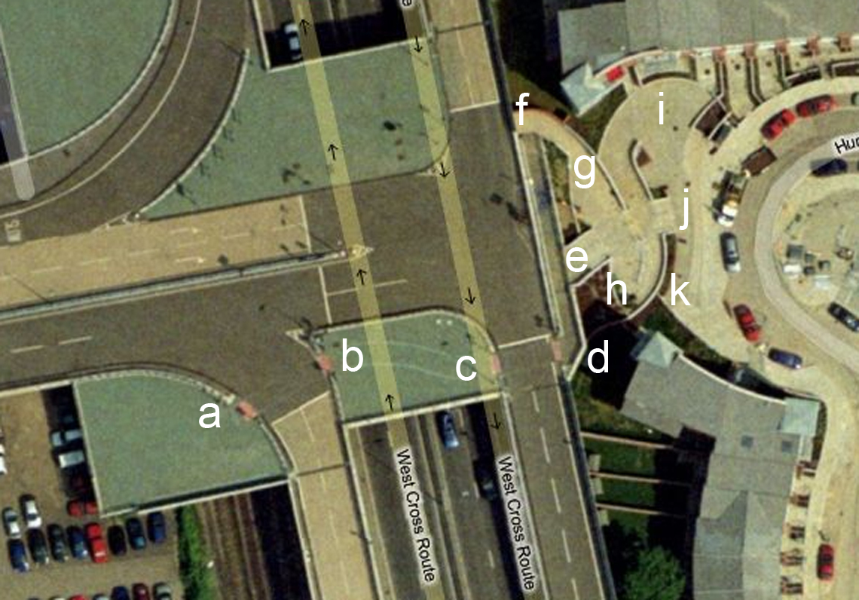

This layout can be seen in the satellite view taken from Multimap. This shows the H – bridge giving access to Westfield from the A3220. On the right hand side is the ramp [d f g h i j k] with sharp bends at [f and h]. Steps [ e – j] cut across the ramp. The roadway at the bottom of the ramp is Hunt Close [LBHF].

From [a to b] and [c to d] crossing the bridge
top section of the ramp [d to f].
The top corner [f] of the ramp is very sharp.
Just below this a retaining wall [g] juts out and restricts the width of the ramp.
At [h] the central railings unnecessarily make the corner harder to get around.
at [k] the ramp meets the pavement there is a slight difference in level.
at [j] no handrails for those using the bottom steps and going straight ahead.

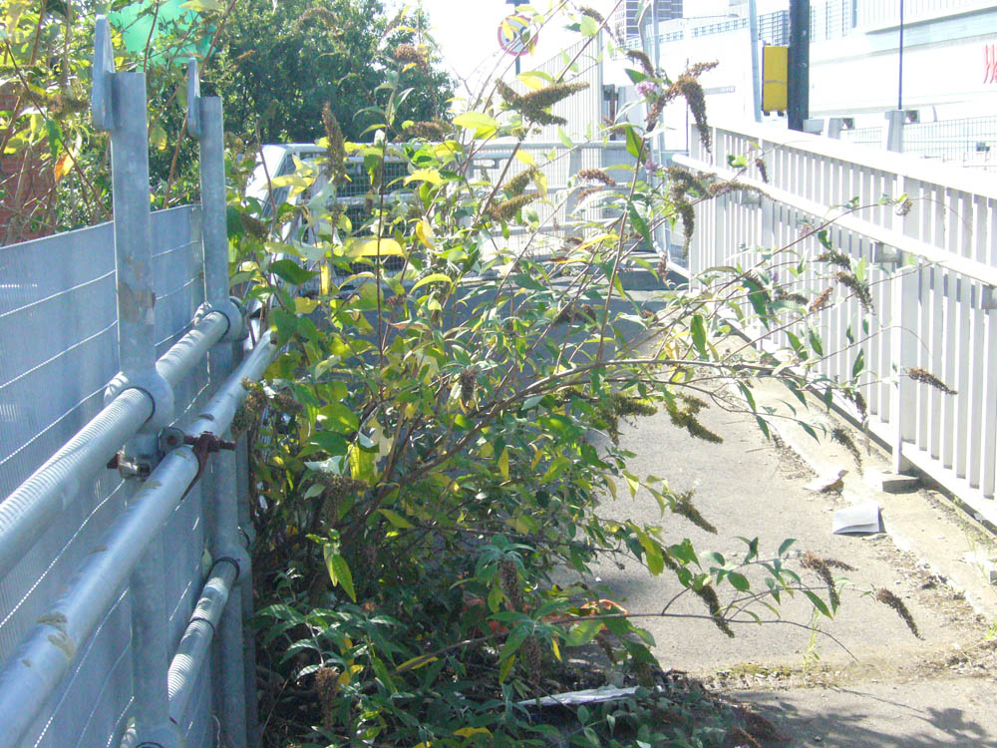
From top of steps [e] looking towards [d] - crossing

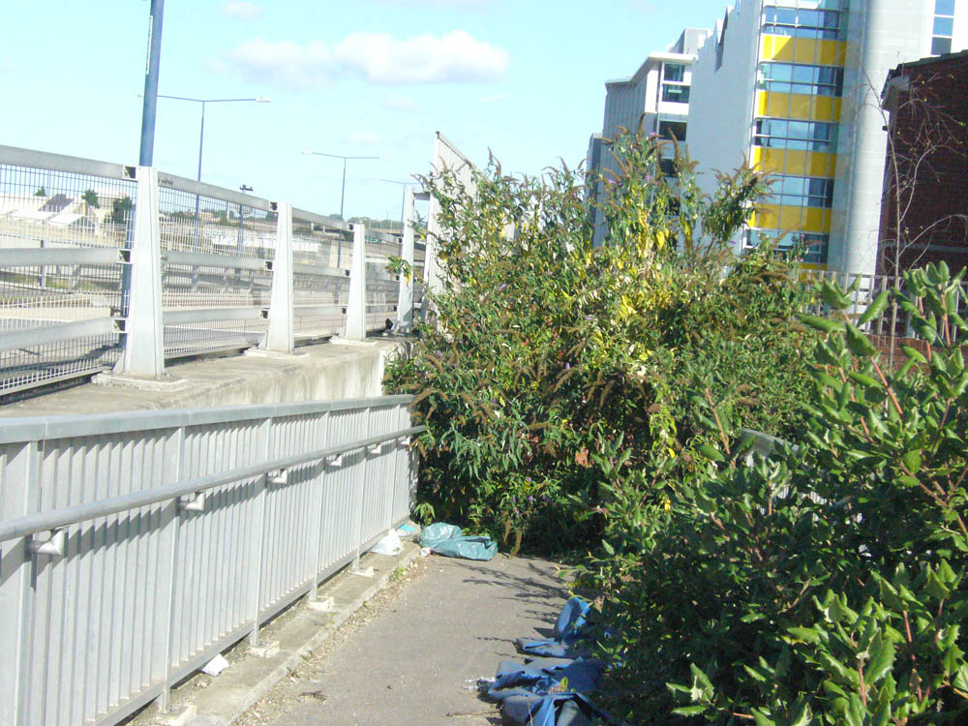

from top of steps [e] looking down ramp towards [f]
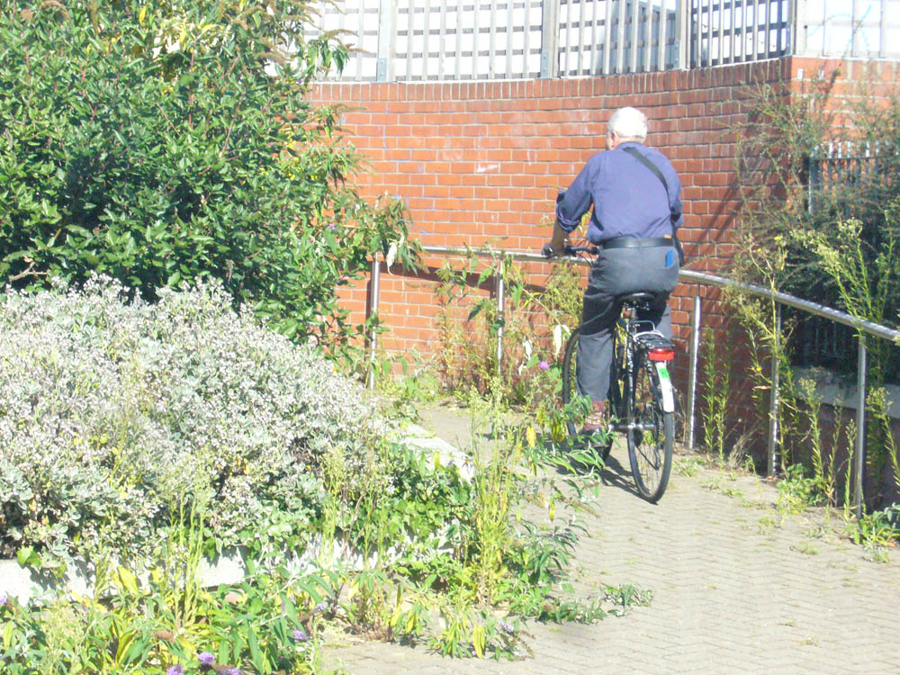
Passing the restriction at [g] and heading towards [f]

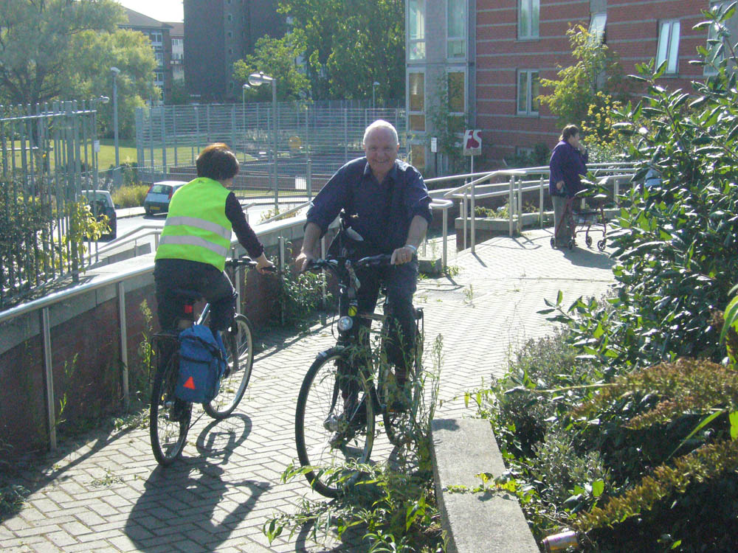

The restriction at [g]
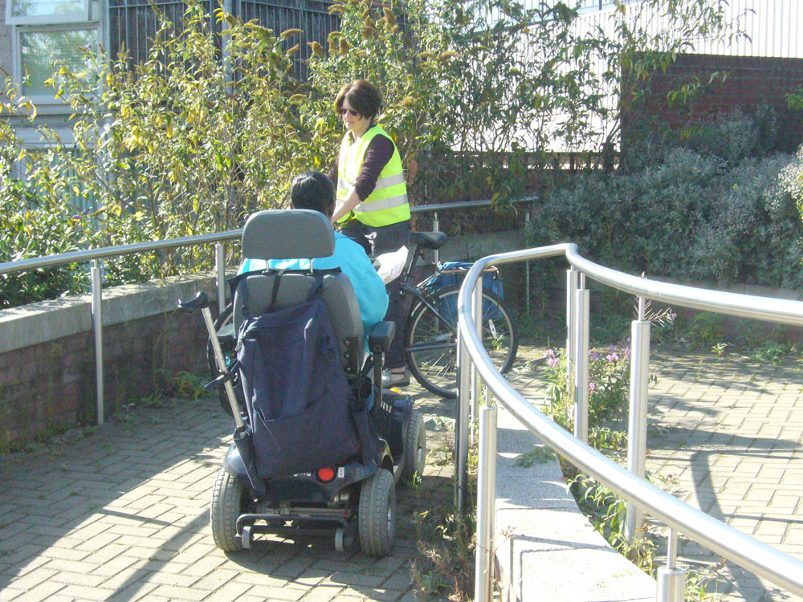
The central railings at [h] could be moved back

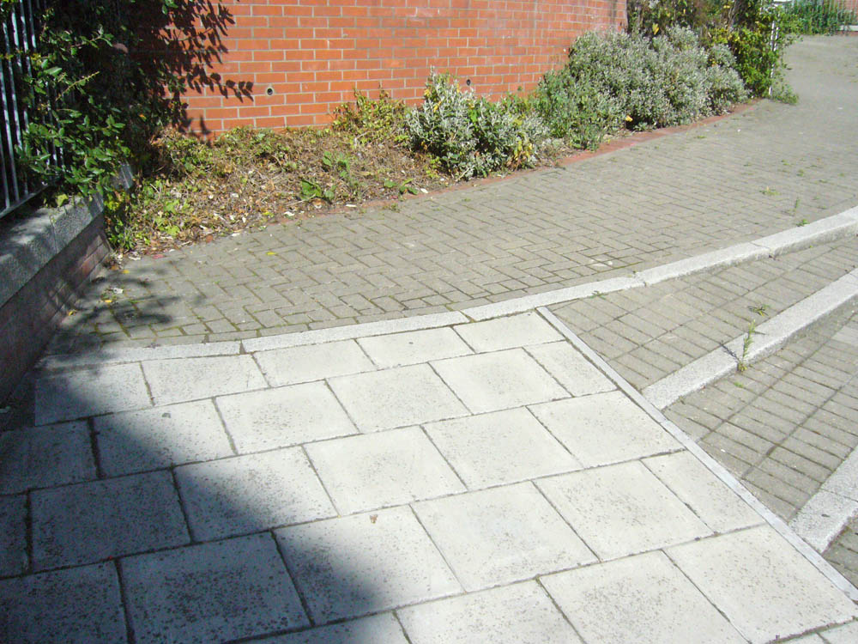
At [k] slight level problem. Also cycle track on ramp ends on footway.

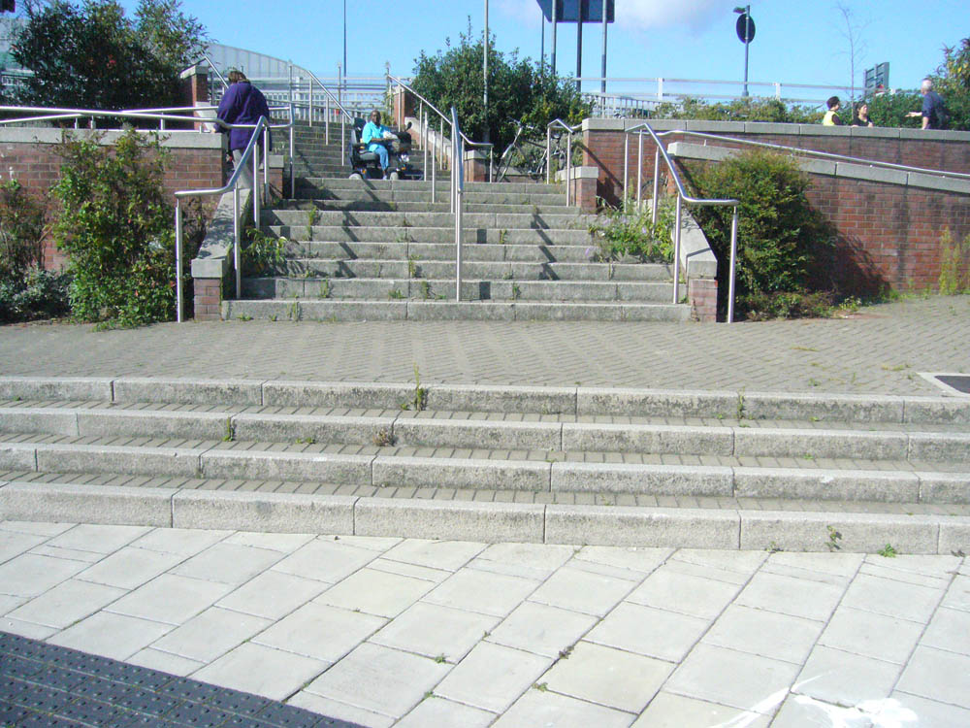
At [j] no handrails.

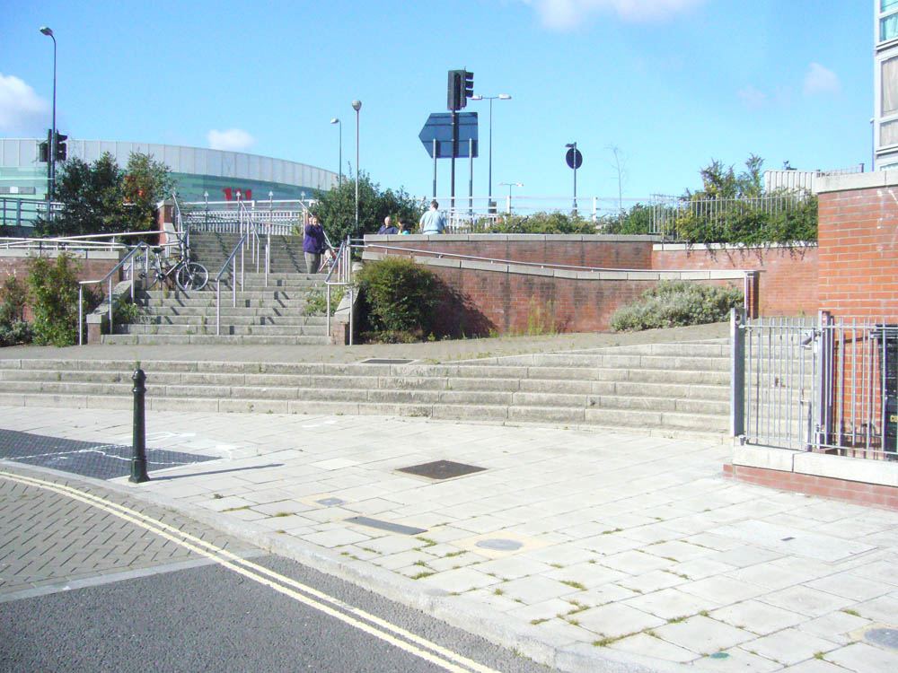
Wider view of the above

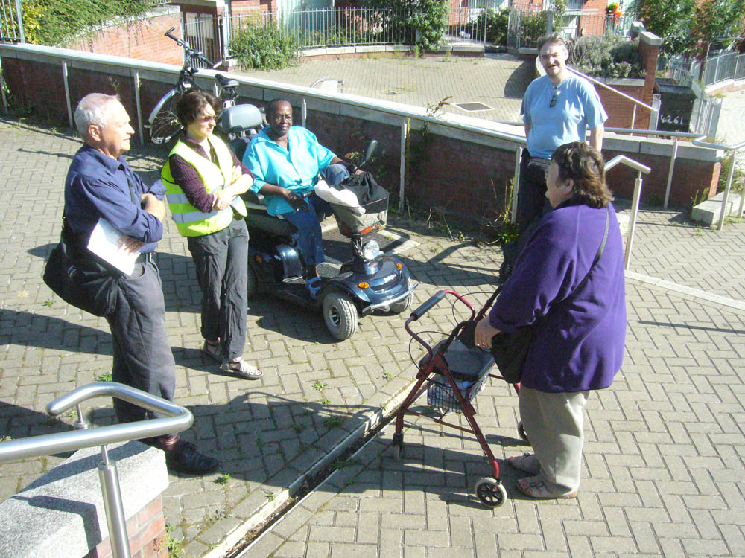
Chris, Sharon, Doreen, Colin and Angela

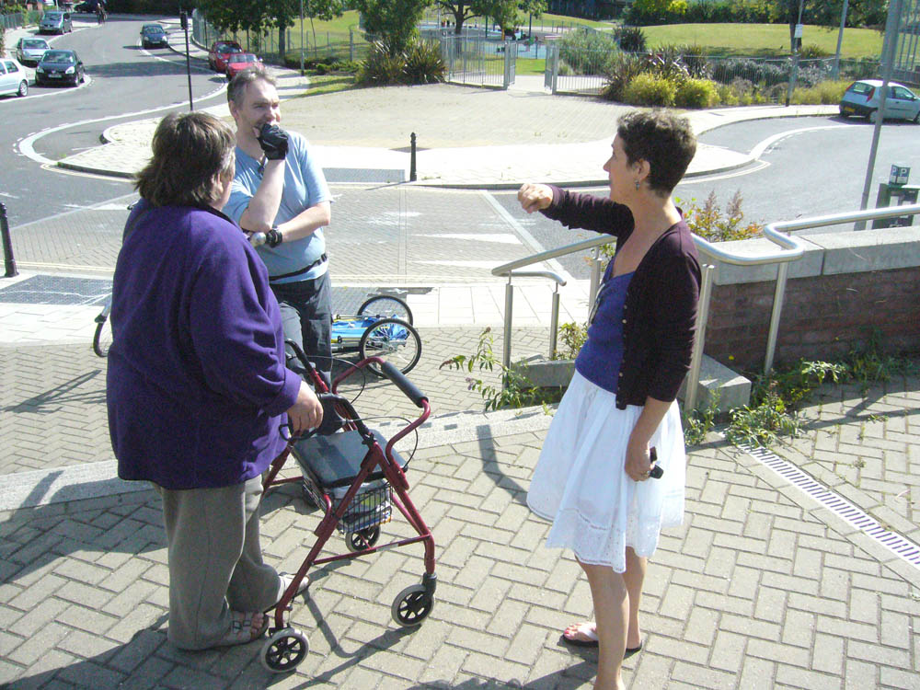
Angela, Colin and Amanda. [photos by John Griffiths]

