THE SOUTHERN INTERCHANGE AND THE WESTFIELD CYCLING STRATEGY.
19 JUNE 2008

1 SUMMARY

1.1 I find several problems with the design involved with the Southern Interchange and with Westfield’s plans for cycling. This paper should be construed as an objection to the planning applications. 2007/02266/FUL, 2008/01417/DET, 2008/01603 DET

1.2 The method of taking cyclists off the carriageway of the Uxbridge rd presents a problem. At present cyclists on the main LCN+ route 73 into London are expected to leave the carriageway through the dropped kerb of a toucan crossing where pedestrians and other cyclists may be waiting to cross. I hope this may receive proper design care.

1.3 There are problems in the location of the toucan crossing. It is not in the most convenient place and those waiting to cross may block the flow on the footway.

1.4 There is a problem of whether the carriageway of the Uxbridge rd is wide enough to carry 4 lanes of traffic now that the footway has been widened. There is conflicting material in the planning applications.

1.5 There are fundamental problems concerning the lane widths on a curve, as a long vehicle on a bend requires a wider lane than normal. The toucan crossing acts as a break between two straight sections of the Uxbridge road. However the geometry actually constitutes a sharp bend in the road, with no lane markings. The Uxbridge rd [A4020] and Shepherds Bush Green [A402] are part of the Strategic Road Network [SRN], and the design guidelines call for much greater lane widths than shown.

1.6 This is an amazing opportunity for the Environment Department of LBHF to improve the urban space of Shepherds Bush. It could become a pleasant space that people enjoy being in and passing through, both as pedestrians and cyclists. It would improve health and reduce pollution and congestion. The Director for the Environment should be making this happen.

1.7 Some drawings have been used from the LBHF planning website for the purpose of facilitating this consultation. The originals can be accessed at
www.apps.lbhf.gov.uk/PublicAccess/tdc/DcApplication/application_searchform.aspx
and by putting in the relevant Application No, ie 2007/02266/FUL for the SI application.

1.8 FROM:
John Griffiths, chair hfcyclists – local branch of the LCC in Hammersmith and Fulham
122c Edith rd, West Kensington, W14 9AP, / 020 7371 1290 / 07789 095 748
www.hfcyclists.org.uk / john@truefeelings.com
2 PROBLEM OF HOW THE TOUCAN CROSSING WILL DEAL WITH CYCLISTS AND PEDESTRIANS.

2.1 The present plans according to the landscaping application [2008/01603 DET] drawing 424966

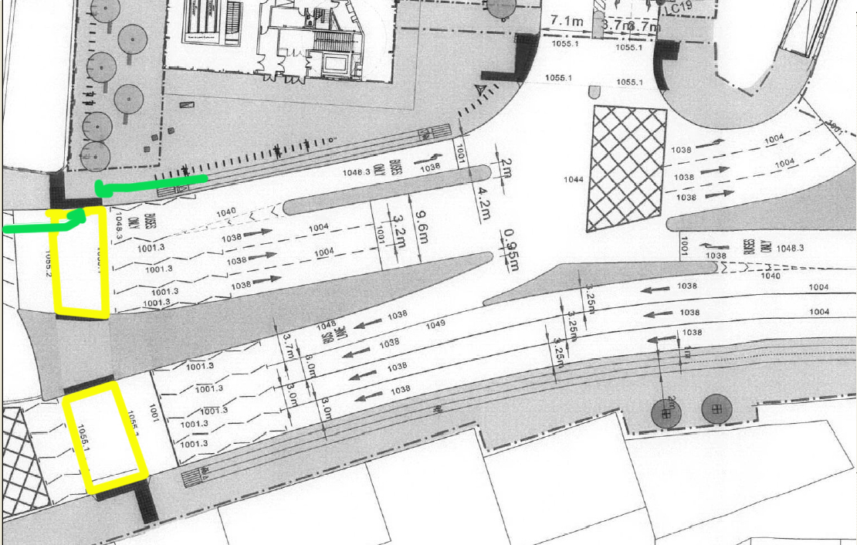

I have outlined the Toucan crossing in yellow. The green arrows represent the paths that cyclists are expected to take. There will also be pedestrians waiting to cross when the traffic is flowing.

The method of leaving a busy carriageway [Uxbridge rd] into and through pedestrians and cyclists waiting to cross on the toucan crossing is to be deplored. The danger of not being able to exit the carriageway because the dropped curb is blocked with waiting pedestrians is excessive. Fast moving buses will be following close behind the cyclist.

2.2 On the present design, in the event of a fatality or serious accident to a cyclist I imagine that the Council as Highway authority would be liable. The Westfield Cycling Strategy calls for full design and audit ahead of implementation of this crossing, at page 86.

Some of the proposals, for example the routes through the Southern Interchange and the Uxbridge Road toucan facility, which will encompass these elements, should be subject to detailed design and audit ahead of implementation.

2.3 I include a suggestion as to how the danger to cyclists leaving the carriageway of the Uxbridge rd may be reduced. This also removes the problem of the narrow 2 way cycle track between the cycle stands and the carriageway.

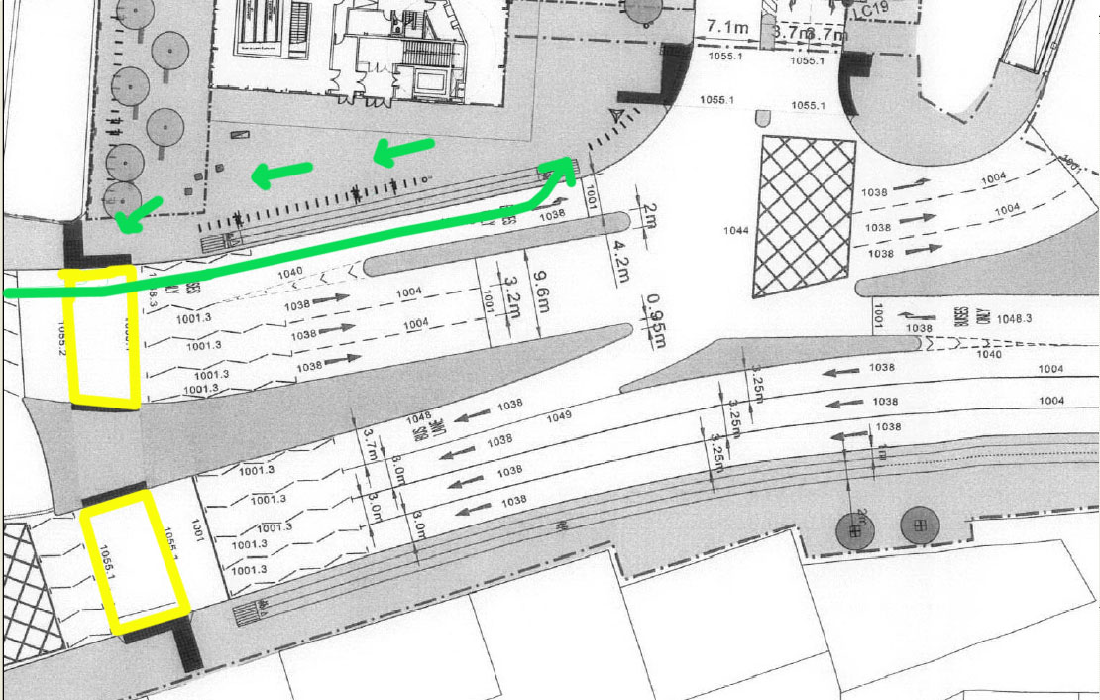

Perhaps LBHF will call upon the free design advice available from Cycling England to provide expert help in this matter.

2.4 HOW LEAVING THE CARRIAGEWAY SHOULD BE DESIGNED,

According to the London Cycling Design Standards
http://www.tfl.gov.uk/assets/downloads/businessandpartners/lcds_chapter4.pdf

Chapter 4
Links – Cycle lanes, cycle tracks and other cycle facilities

Transition between cycle lanes and cycle tracks
4.2.44
It will occasionally be necessary to provide a transition from on-carriageway cycle lanes to off-carriageway cycle tracks and vice versa. This transition should be clear, smooth, safe and comfortable for cyclists. Minimum speed change and vertical and/or horizontal deviation for cyclists should be the objective. Drawing CCE/C4 shows a typical detail for this situation.
London Cycling Design Standards

C4.1 / C4.2 show tracks joining carriageway. / C5 shows track joining crossing.
2.5 I HAVE URGED THE COUNCIL TO REVIEW SAFETY OF THE DESIGN AT THE TOUCAN CROSSING

I have also urged that the Council carry out a non-motorised audit of the area around this crossing, and have had a response from Cllr Nick Botterill, as below.

FROM the minutes of Full Council meeting 27 February 2008, Appendix 2 , Q3

http://www.lbhf.gov.uk/Images/Agenda_tcm21-97855.pdf

QUESTION
“Westfield have designed the Southern Interchange to accommodate predicted traffic and bus flows. LBHF are using the designs presented to them by Westfield, or more precisely by their transport consultants Halcrow. Westfield have conducted a Non-Motorised User audit for that part of the Southern Interchange that is on Westfield land, to seek out and reveal dangers to vulnerable road users.

Westfield have not conducted a Non-Motorised User audit for that part of the Southern Interchange that is on LBHF land. The proposed Toucan Crossing across the Uxbridge rd and Shepherds Bush Green, part of the Southern Interchange, has been designed by Westfield to cater for pedestrians and cyclists on LBHF land. Cyclists will be using the carriageway designed by Westfield on LBHF land.

Has LBHF conducted a Non-Motorised User audit for that part of the Southern Interchange covered by the Planning Application 2007/02266/FUL that is on LBHF land, and if not when will it be completed, and what figures are LBHF using for the predicted pedestrian and cyclist flows on the crossing, and, for cyclists, on the carriageway and cycle tracks?”

RESPONSE:
Non motorised road user audits are used to assess performance and conflict within pedestrianised areas such as town centres and transport interchanges. It is not a recognised approach to apply them to strategic road junction redesigns where the standard road safety audit procedures will pick up any conflict points between non motorised users and motorised traffic.

The final design of the southern interchange was the result of over six months worth of multi agency discussion, modelling and negotiation involving the developer, the local and strategic road authority, London Buses, London Underground and Transport for London’s traffic signal management team. Many design options were deliberated over and investigated until the final design was agreed upon, based on the results of many
performance indicators.

The predicted levels of pedestrian and cyclist activity through the southern interchange has been supplied by the developer based on industry recognised methods, and agreed by the both the relevant highway, traffic and transport authorities, Hammersmith and Fulham Council and Transport for London. The resulting design is one that can achieve the best use of the limited available road space to accommodate all road users.
3 THE POSITION OF THE CROSSING AS A FEATURE OF URBAN DESIGN

3.1 The present plans according to the landscaping application [2008/01603 DET] drawing 424966

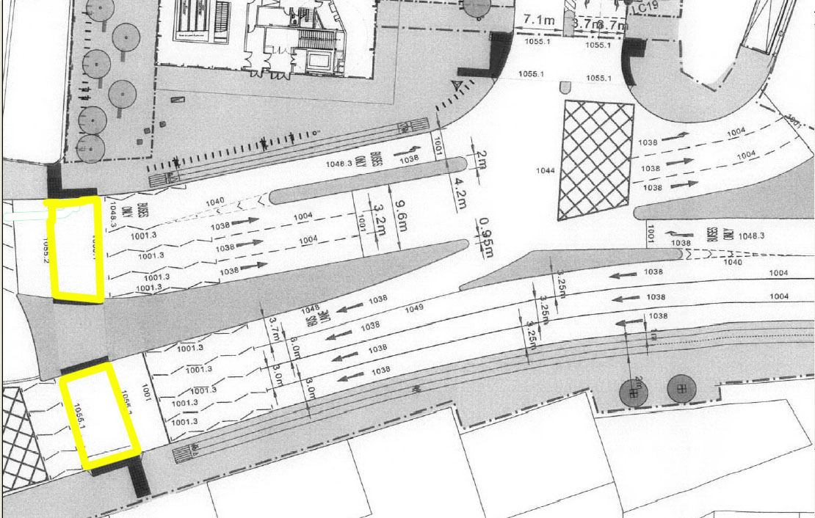

The Toucan crossing is outlined in yellow. The crossing is at the narrowest possible part of the footway of the Uxbridge rd. On the other side he entrance to the West 12 Centre is opposite the black mark indicating the textured paving leading to the crossing.

The footway of the Uxbridge rd is likely to be restricted by pedestrians and cyclists waiting to cross. In the confined space a small number of waiting pedestrians and cyclists will quickly lead to restriction of the footway.

Pedestrians leaving the Central line station and crossing to go east have a longer journey than necessary. This is urban design by traffic engineers. The sensible place for the crossing is opposite the station, with a wide space open space behind it.

The reasons given for not considering a change are:
that buses may bunch – so what , there is no room at the stops for them anyway,
and that the crossing is in the most convenient position, which it very obviously is not.
and the fact that planning permission has already been given.
[see letter dated 27 March 2008 from Cllr Nick Botterill attached at end]

3.2 This is an amazing opportunity for the Environment Department to improve the urban space of Shepherds Bush through urban design, and it should be taken.

4 PROBLEM OF THE POSITION OF KERB LINE, AND LANE WIDTHS

4.1 The supporting statement 346703 of the Southern Interchange Application 2007/02266/FUL shows a kerb line that was different from the present configuration.
It appears that the developers were using plans that were many years out of date.

[Note that the red dashed line shows the area of the Southern Interchange application].

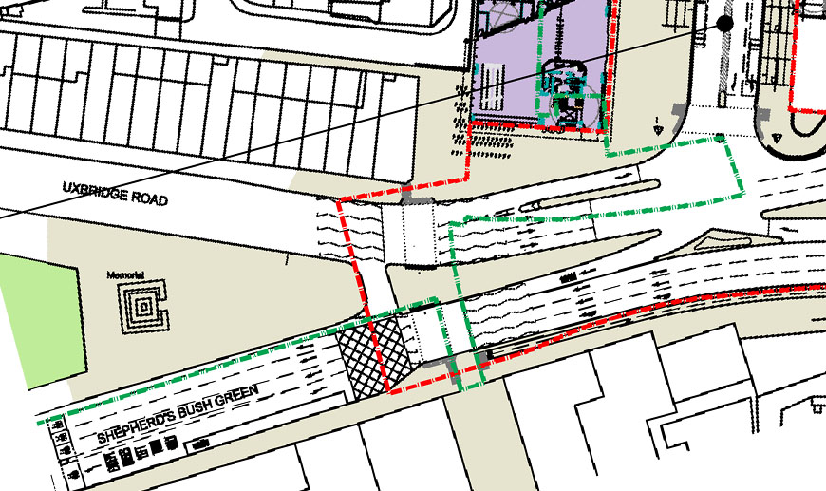

4.2 The drawing 420848 that accompanied the application [2008/01417/DET] that includes the Westfield Cycling Strategy has a plan that shows what appears to be the present footway layout.

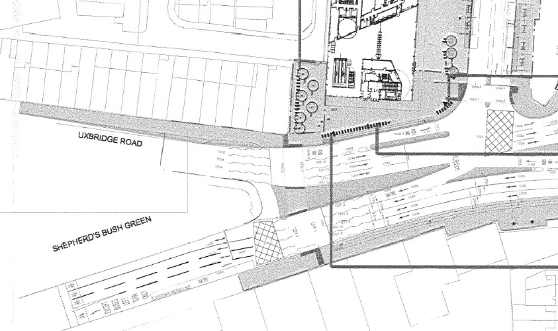

4.3 There was a discussion about the kerbline situation in the Supporting Statement-346709 to the SI application 2007/02266/FUL

Appendix C. stage 1 road safety report.

designers response at p22/35
and at p27/35

A3.2.1
Problem Uxbridge road has recently been changed to a widened footway, a bus lane and two traffic lanes. The design drawing shows 4 lanes approaching the toucan crossing. This does not seem to correlate with the existing situation.

Recommendation
It may be proposed to revert Uxbridge road to 4 lanes but, with the widened footway, this looks unlikely. It may be necessary to adjust the design proposals accordingly.

Designers response

The proposed design will change the existing kerbline on Uxbridge Rd - this has been through analysis and discussions with LBHF and TfL Walking and Cycling team.

4.4 Presumably the traffic modelling was done on these road plans that show the configuration before the footway was widened on the north and south sides, many years ago.

4.5 I have questioned what was happening. Cllr Nick Botterill reported to me in an email dated 17 August 2007 that the footway will be narrowed in places. [see Appendix KERBLINE]

This is not shown in the latest landscaping application. It is still not clear what is planned.

A planning application that is based on invalid information should NOT BE CONSIDERED VALID, or at least should be open to objection and revision.

5 FUNDAMENTAL PROBLEM OF LANE WIDTHS ON CURVES

5.1 There are fundamental problems concerning the lane widths on a curve, as a long vehicle on a bend requires a wider lane than normal. The toucan crossing acts as a break between two straight sections of the Uxbridge road . However the geometry actually constitutes a sharp bend in the road, with no lane markings.

5.2 The Uxbridge rd [A4020] and Shepherds Bush Green [A402] are part of the Strategic Road Network [SRN], and the design should follow the guidelines of the Design Manual for Roads and Bridges [DMRB]. This calls for much greater lane widths than shown. The DMRB Volume 6, Section 1, Part 1, Chapter 3,

Widening on Curves
3.9 Widening of curves on links and on the main line through junctions is required for carriageways of less than standard width and for low radius curves of standard width to allow for the swept path of long vehicles.

5.3 The radius of the curve on the eastbound carriageway of the Uxbridge rd at the Toucan crossing appears to be 80m or less. The DMRB suggests lane widths of 3.8m or 4.0m are in order in such cases.

[From drawing 420848 that accompanied the application 2008/01417/DET]

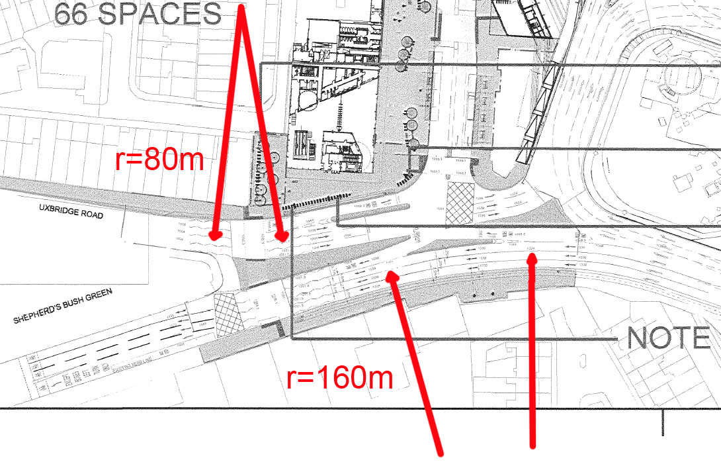

An example of lanes being wider on a curve: the westbound lanes of Shepherds Bush Green are wider on the curve at 3.25m and narrow to 3.0m as they approach the Toucan crossing. The radius of the curve here appears to be about 160m.
5.4 On the westbound carriageway of Shepherds Bush Green just after the Toucan there is a sudden kink in the lanes, which also may be a problem for long vehicles if the lanes are narrow, and which is partially obscured by road hatchings.

5.5 A more precise drawing suggests the radius is closer to 65m on this bend in the Uxbridge rd. Many cyclists are expected to be on the carriageway passing through this area.

[from drawing 424966 of the landscaping application 2008/01603 DET]

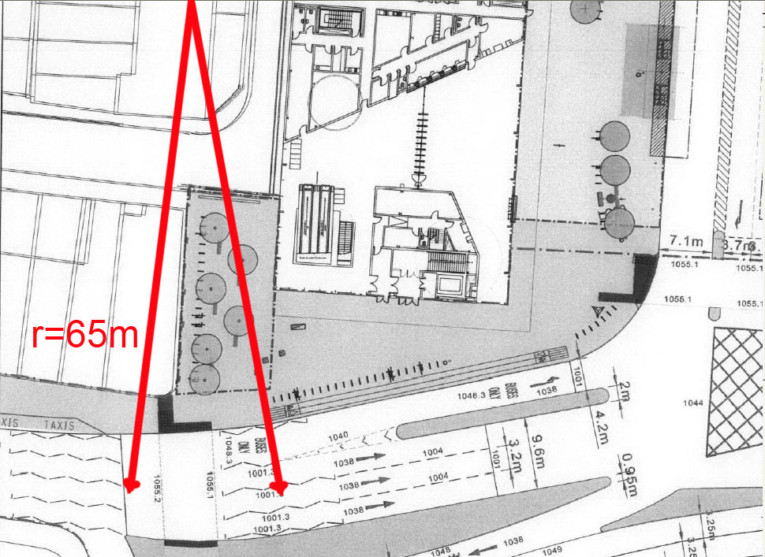

5.6 The Uxbridge road is carrying a lot of HGV’s on the narrow lanes that showing no signs of widening on the bend. As the lane markings are obscured by a crossing, this road layout would appear a little dangerous.

Are the lane configurations of the Uxbridge road valid?

Has this really passed the approval of all the agencies involved?

Evidence shows that many cyclists use the carriageway, and the design of the road layout should take full account of their vulnerability. I hope the situation here will be fully appraised and the layout altered if necessary.

See APPENDIX DESIGN MANUAL FOR ROADS AND BRIDGES
APPENDIX KERBLINE

----- Original Message -----
From: Nick Botterill
To: john griffiths
Cc: Eugenie White ; Andrew Johnson
Sent: Friday, August 17, 2007 10:26 AM
Subject: Response to your concerns

John

I have received a response from officers about the 3 concerns you noted to do with SBG which is as follows:

1) There are no plans to reverse the footway widening and crossing improvements on the west and south sides which we have undertaken in the last few years.

2) However, the area around the southern interchange is extremely constrained and has to handle large amounts of movements of pedestrians, cyclists, buses and general traffic. The plans are still being finalised but there may have to be a small amount of footway narrowing at pinch points near the interchange and on the south side to the east of the W12 shopping centre.

3) At the beginning of August, there was a CRIM (Cycle Route stakeholder inspection meeting) on Uxbridge Road, at which John Griffiths was present and which looked at the issues he raised in relation to access to and from the Holland Park roundabout. Minutes of that meeting are at present being finalised, following which a post inspection meeting will beheld, to which John Griffiths will be invited, to develop options and
solutions.

Can I assure you John that any final plans will have to be agreed by the senior officers and myself. All the best.

Nick Botterill

27th March 2008

DLDR/NB/MSH
London Borough of Hammersmith & Fulham
Councillor Nicholas Botterill
Deputy Leader and Cabinet Member for Environment
Room 221, Hammersmith Town Hall, King Street, London W6 9JU
Tel: 020 8753 1088
Email: nicholas.botterill@lbhf.gov.uk
Web: www.lbhf.gov.uk

Mr John Griffiths

Sent via email:
truefeelings@btinternet.com

Dear Mr Griffiths,

RE: Pedestrian and Cyclist access

Thank you for your petition which was submitted on 14th February.

I called a special meeting with Councillor Ivimy, who chairs the Planning Applications Committee, Councillor White, who chairs the Cleaner Greener Scrutiny Committee and senior council officers Graeme Swinburne, Assistant Director Highways, Chris Bainbridge, Transport Planning Manager, Nick Boyle, Traffic and Road Safety Manager, and Julian Renselar, Team Leader Enforcement and Special Projects.

The fact that we called together these very senior people indicates how seriously we take pedestrian and cyclist access.

The officers took us through how the present proposals had evolved, after many months of negotiations with a range of bodies, including bus, traffic, traffic signal, strategic road and cycling and pedestrian sections of TfL, and the Royal Borough of Kensington and Chelsea . The current layout has been agreed with all parties, and any major changes are likely to result in traffic tailbacks over a wide area. On specific issues such as bus queuing space, we felt that the proposed provision was appropriate, given the propensity of buses to bunch. We consider it is very important that the shopping centre provides a good public transport offer in order to minimse traffic generation and congestion. We note that the proposed toucan crossing between the interchange and the W12 centre will be 7.5 metres wide compared with the present 4 metres. The crossing appears to be in the most appropriate location, as the desire line of pedestrians from the interchange is towards the W12 centre and the west.

We asked officers to provide cycle parking in the centre island by the crossing and also on the south side of the green both to repalace those which are being removed and to provide more for the W12 centre.
A toucan crossing is to be provided across the A3220 giving a safer alternative for cyclists than using the roundabout and a pleasanter alternative for pedestrians than the existing subway, which is being retained and refurbished.

There is a commitment to produce a cycling strategy, which is unusual for a shopping centre of this size, and has been suggested as an example of best practice. There is a commitment to provide over 500 cycle parking spaces and two new cycle routes through the development. I understand that you have been closely involved in its development and we share your view that cycle parking should be much more conveniently located than previous plans from Westfield have shown. We understand that a revised version is being developed.

Our view on cyclists getting through the southern interchange is that this should be shared use, with "cyclist give way to pedestrians" signs and landscape designed to prevent cyclists speeding, a similar view to your own.

The new West London Line and Hammersmith and City line stations will have step free access and TfL are now considering an alternative scheme for providing lifts at the Central Line station.

We believe that all the above demonstrates a high degree of priority and commitment to the needs of pedestrians, disabled people, public transport users and cyclists in accordance with Network Management Duty and DfT guidance.

When the details of the southern interchange design have been finalised, they will be subject to a Stage 2 safety audit, which gives high priority to the needs of vulnerable road users, and modifications will be made to the design as appropriate. We will also monitor the working of the interchange during its first few months of operation, and make changes as appropriate.

However, we have to recognise that the essential nature of the Holland Park roundabout as an area of heavy motor traffic will not change.

Yours sincerely

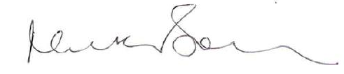

Councillor Nicholas Botterill
Deputy Leader and Cabinet Member for Environment

APPENDIX DESIGN MANUAL FOR ROADS AND BRIDGES

Some relevant sections of the DMRB that apply to the Strategic Road Network

Highway Link Design /
http://www.standardsforhighways.co.uk/dmrb/vol6/section1/td993.pdf

Volume 6 Section 1 Part 1 TD 9/93 / Chapter 3 Horizontal Alignment /
Widening on Curves

3.9 Widening of curves on links and on the main line through junctions is required for carriageways of less than standard width and for low radius curves of standard width to allow for the swept path of long vehicles.

3.10 For Carriageways of Standard Width, (7.3m, 11m, and 14.6m for 2, 3 or 4 lanes respectively), an increase of 0.3m per lane shall be allowed when the radius is between 90m and 150m. Two lane roads of width greater than 7.9m require no additional widening.

3.11 For Carriageways less than the Standard Widths, widening shall be:

0.6m per lane where the radius is between 90m and 150m subject to maximum carriageway widths of 7.9m, 11.9m and 15.8m (for 2, 3 and 4 lanes respectively).

0.5m per lane where the radius is between 150m and 300m, subject to a maximum width not greater than the standard width in Paragraph 3.10 above.

0.3m per lane, where the radius is between 300m and 400m subject to a maximum width not greater than the standard width in Paragraph 3.10 above.

3.12 Radii less than 90m on the mainline are Departures from standard. For these and all other junction elements, widening should be in accordance with TA 20 (DMRB 6.2).

Geometric Design of Major/Minor Priority Junctions
http://www.standardsforhighways.co.uk/dmrb/vol6/section2/td4295.pdf

Volume 6 Section 2 Part 6 TD 42/95 / Chapter 7 Geometric Design Features
Carriageway Widths around Curves

7.25 Where carriageways are taken around short radius corners, added width shall be provided to cater for the swept area of larger goods vehicles and the "cut in" of trailer units. On single lane sections greater than 50m in length an allowance shall be made for broken down vehicles as in para 7.21. Table 7/2 shows the recommended minimum widths for various nearside corner radii based on the design vehicle. For radii above 100m, the standards set out in TD 9 (DMRB 6.1.1) shall be used.

Inside corner radius/m 10 15 20 25 30 40 50 75 100
Single Lane width/m 8.4 7.1 6.2 5.7 5.3 4.7 4.4 4.0 3.8

Figures taken from table 7/2 DMRB TD42/95

