Westfield’s WhiteCity London

Not all is well at Shepherds Bush Green and Holland Park Roundabout [SBG / HPR]

Halcrow, the Transport consultants for Westfield, have designed the Southern Interchange. They are also assisting lbhf to progress the local road layout. The WhiteCity London complex hopes to open by mid October 2008.

The essence of their planning is to get buses and visitors’ cars into the complex. Pedestrians and cyclists have to fit into any space left over. The result for pedestrians, cyclists and the built environment of SBG is not pleasing.

SBG / HPR is a main cycling thoroughfare into London and is one of the barriers on the LCN+ that is meant to be resolved by 2010. Also the Common at SBG is being redesigned by landscape architects Whitelaw Turkington to make it a desirable urban space. [see Section PLAN below]

Problems with the Transport Assessment and modelling outcomes

The Transport Assessment 2006 is in my opinion obfuscating, seriously flawed, and written to obtain planning consent. They give annual visitors as 21.47M, and visitors on a Saturday as 75.3K. Transparent methods used in other TA’s would give a Saturday figure of 90K - 98K. Halcrow make no allowance for seasonal variations, and the numbers of visitors on a Saturday in December would be expected to be 136K [see Section VISITORS below].

One would expect that the number of cars would have been found by dividing the number of visitors coming by car by the assumed occupancy. But not so.

There are also inconsistencies in the Westfield TA 2006 to do with the car park figures [see Section CAR PARK below].

The Westfield TA 2006 does not predict any unacceptable queuing, though it is a very close call. Should more cars arrive than predicted and at a rate faster than they can get in, queuing will result.

A serious problem is that the car park exit is very vulnerable to being blocked. This may arise from external network congestion, or from Westfield traffic queuing back. There is then a positive feedback loop cementing the situation. Some may call this GRIDLOCK
[see Section QUEUING below].
Things that could be done urgently to ameliorate the situation.

- Revisit the inputs to the model, vulnerability to network conditions, feedback possibilities leading to gridlock.
- Consider a car park entry toll, equivalent to the congestion charge or more, to reduce travel by car to the development to a manageable level.

And some elements of the design

- Move the crossing outside Central line station away from position whereby those waiting to cross the road are blocking footway flows.
- Close the bus cut-through at the apex of the Common scheduled to be used by one bus every 2 – 3 minutes. These buses can go round the roundabout. This produces more laminar flows. It opens up a route for pedestrians and cyclists to access the Common at this point. There are tremendous advantages for the Common which is being redesigned.
- Allow westbound cyclists from HPR on the cycle track to get through the crossing outside the W12 Centre on a green light. [not allowed in present design as an extra metre on pedestrian crossing distance means 2 seconds off vehicle green light. As it stands cyclists will be competing with pedestrians to get across the space]
- Allow cyclists a clear passage to get past gridlocked traffic at all places.

Westfield and Halcrow do not seem to have the interests of West London at heart. Serious gridlock will damage the economy. If there is not room for cyclists and pedestrians then traffic reduction measures must be considered at this stage.

I hope you will be able to look into this matter.

John Griffiths
[chair / co-ordinator hfcyclists - local branch of London Cycling Campaign]
122c Edith Rd, W14 9AP
020 7371 1290 / 07789 095 748
john[at]truefeelings.com
www.hfcyclists.org.uk

3 December 2007
Section PLAN

From Westfield’s Planning Application for the Southern Interchange

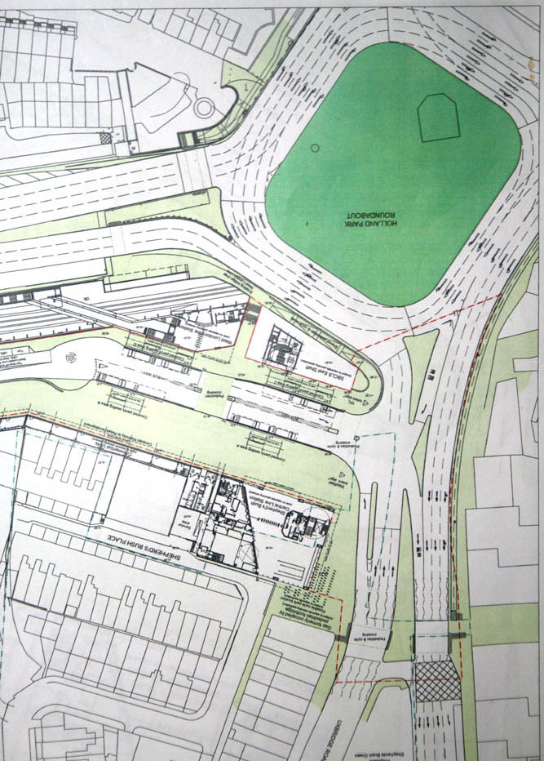

To see plans of Westfield’s application for the Southern Interchange, Go to www.apps.lbhf.gov.uk/PublicAccess/tdc/DcApplication/application_searchform.aspx
Put 2007/02266/FUL into the Application No box, and click SEARCH at the bottom,
CLICK “Click to view” / CLICK “Associated Documents” Tab
CLICK “View associated documents
Go to TRANSPORT STATEMENT - MAIN REPORT
CLICK “whole document” / go to page 17 of 18 to see the original pdf
Section VISITORS

The Westfield TA 2006 on p39, Table 4.2, gives the visitors expected to come by different modes, and I have added totals.

Daily Arrivals to Whitecity

Mode of Travel Friday Saturday Sunday
…………….
Total Rail 21810 25890 13630
Total Walk/Cycle 4170 4950 2600
Total Bus 9480 11260 5920
Total Car 27980 33220 17480

[total visitors 63440 75320 39630]

Table 4.2: Daily Visitors to Whitecity development by mode of travel
(based on worst case of 21.47 million visitors per year.)

The derivation of these figures is obscure, and refers to assumptions made in the Westfield 2002 TA, which does not give all assumptions, and which refers one to the 2000 Halcrow document. The 2006 TA also relies on the Parker paper of 1985.

A lucid explanation of how to derive daily footfall from the annual figure is given in Wolverhampton Retail Core Expansion Report Revision P0, Transport Assessment Report, by Buro Happold Ltd 2005 , see APPENDIX VISITORS

Using that method and 21.47M for the annual figure would give for Friday and Saturday

Jan – Nov general shopping 59K 90K
Jan – Nov non-food shopping 59K 98K
December general shopping 89K 136K
December non-food 89K 148K

The Saturday figures are considerably greater than those in the Westfield TA 2006. Why?

They may well lead to unacceptable queuing at the car park entry, and Saturday is the most vulnerable day.

Visitor numbers are not the same thing as car numbers. One would expect a lucid discussion of the car occupancy in the Westfield TA 2006. No such luck.

Section CAR PARK

The Westfield TA 2006 gives at s6.2 Car Park Capacity

In addition using Peter Mynors methodology (HF 2000) the average duration of stay is likely to increase to 2 hrs 30mins

The Westfield TA 2006 has a Figure 6.2 called Parking Accumulation [see graph on next page]. I have made some deductions reading the values off the graph. The points on the graph are for 15 minute intervals, so 4 consecutive values of 500 for the blue diamonds implies car park entry = 2000 vehicles in that hour. There is perhaps a 2% max cumulative errors in reading from graph.

Friday and Saturday Parking spaces

Between 10am and 3pm on Friday there appears to over 1740 vehicles entering each hour. If each stayed for an average of 2.5hr it would require 4350 parking spaces
Yet on Friday there are only 3.500 parking spaces permitted

Between noon and 6pm there appears to over 2200 vehicles entering each hour. If each stayed for an average of 2.5hr it would require 5500 parking spaces
Yet on Saturday there are 4.500 parking spaces permitted.

Peak Friday car park entry

The Westfield TA 2006, at s5.4.2 gives the peak hourly arrival on Friday as 1185.

Reading from the graph gives the peak [ie highest] hourly arrival on Friday as 1931. This is between 11am to noon. Between 3pm and 7pm, where the conventional Friday peak hour may lie, the hourly entry figure is very close to 1300.

Number of people in a car.

From the number of visitors coming by car, and the number of cars, one can work out the occupancy of the car. Using the number of visitors coming by car given previously

On Friday the total of the cars entering = 17776
therefore occupancy per car = 27980/17776 = 1.57

On Saturday the total of the cars entering = 22646
therefore occupancy per car = 33220/22646 = 1.47

The occupancy on shopping trips is usually considered as 1.7. [see Wolverhampton TA] And it is expected to increase on a Saturday. Having a low occupancy figure may help lower the mode share coming by car? No mention of occupancy in Westfield TA 2006
[see appendix CAR PARK for the Westfield TA section on the car park]

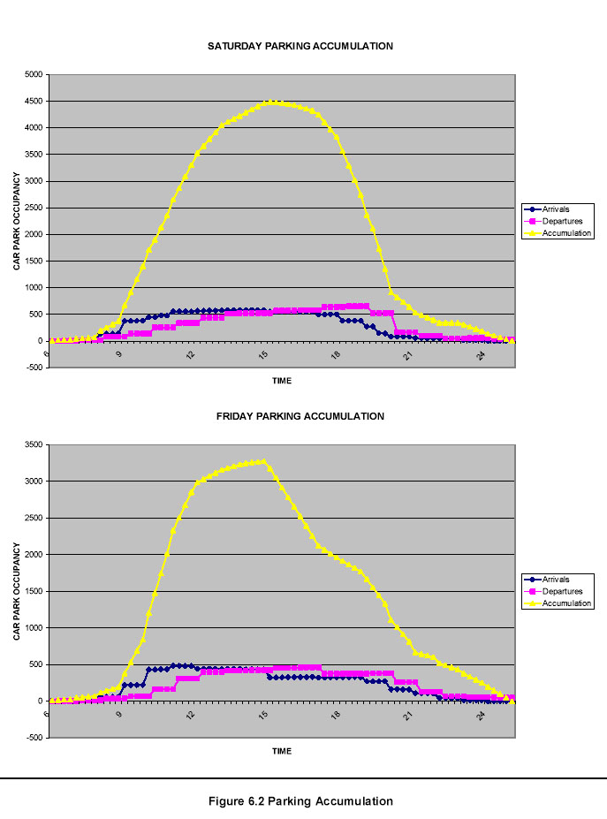
Section QUEUING

Approach figures

The Westfield TA 2006 does not predict any unacceptable queuing, though it is a very close thing. When vehicles arrive at a greater rate than can get in, queuing will result.

If the car park is not full cars can get in at about 2300/ hr.
When the car park is full the entry rate is limited to the exit rate
When the car park is full and the exit is blocked, serious queuing will result

If a queue of 300 cars forms it will stretch back 600m from the car park entrance to the HPR. Often one hears of queues to other shopping centres stretching back for miles.

Congestion blocking the car park exit

There is often congestion on the Network. For example

Last updated: 4.20pm Wednesday 21st November 2007
A402 Holland Park roundabout Shepherd's Bush
Queueing traffic on A402 Holland Park roundabout at A3220 West Cross Route / Shepherd's Bush Green. Possibly due to the closure of the A4 and the delays around Hammersmith and Shepherd's Bush.

Last updated: 1.59pm Thursday 29th November 2007
A40 Westway Acton
Queueing traffic on A40 Westway Westbound between Bloemfontein Road and Old Oak Road / Old Oak Common Lane (Savoy Circus).

http://localinfo.ealingtimes.co.uk/li/traffic.in.Ealing
Information supplied by Trafficlink (UK) Ltd.

A serious problem is that the car park exit is very vulnerable to being blocked, either from external network congestion, or from congestion originating from a queue at the car park entrance feeding back to block the car park exit via the HPR.

There is then a positive feedback loop solidifying the situation. The queue trying to get in blocks those trying to get out. As those trying to get out are blocked in, it means the queue going in will not be moving at all, and will just get longer.

Particularly vulnerable is the right hand turn out of Ariel way to go north up Wood lane. This is at 96% capacity, and when blocked will feed back to block the car park exit.
[see appendix QUEUING].
APPENDIX VISITORS

The Wolverhampton Retail Core Expansion Report Revision P0, Transport Assessment Report, by Buro Happold Ltd 2005 , is very lucid and transparent, and can be found at

http://www.wolverhampton.gov.uk/NR/rdonlyres/0FFCA589-18D8-4769-A848-9ECEC5995A48/0/050413TAAppendiciesRev_P0Volume2.pdf
or http://tinyurl.com/2lq2n4

at p155 / 219

1.2.4 Retail Visitor Population
…..
The information above allows a robust basis for estimating the number of shoppers per year that a given quantum of retail floor space will generate. This data needs to disaggregated to represent the time periods identified by the assessment. This has been achieved as follows:

• Conversion of annual to monthly shopper numbers by application of data contained in Retail Sales Business Monitor Report SDM28 (May 2004). This allows the proportion of shopper trips per annum which occur in a typical month to be calculated. This gives a figure of 8%. By way of comparison December, when retail activity peaks, accounts for 12% of annual retail activity.

• Weekly shopper activity is then calculated by dividing the number of days in a week by the average number of days per month hence 7 / 30.4 = 23%.

• The profile of shopping activity across each day of the week is then derived based on ‘Travel to the Shops in GB - Personal Travel Factsheet 6 (January 2003) published by National Statistics. This factsheet states that 15% of shopping trips are made on a Friday and 22% are made on a Saturday.

[The fact sheet actually gives 23% for a Saturday, 25% for non food, and 30% for people working full time]

The “Business Monitor SDM28” referred to is produced by the Stationery Office, London, and is part of the National Statistics. This publication comes out monthly and gives the indices for quarterly and monthly variations of sales by sector and store type.
[http://www.statistics.gov.uk/StatBase/Product.asp?vlnk=1478]

So as an example on page 41 of the May 07 edition, Other specialized non-food stores, large businesses, 2006, it gives indices

Sept = 144 Oct = 153 Nov = 181 Dec = 270

This shows that the value of goods sold in this sector has increased from September to December to 187% of the September value. Perhaps the number of trips to Westfield will also increase markedly with seasonal variations and sales.

Perhaps using 1.5 as the ratio December / rest of year is lenient and for this type of shopping and perhaps it should be 270 / 144 = 1.87
“Travel to the shops in GB – January 2003”

The Wolverhampton TA also refers to the Department for Transport publication - Personal Travel Factsheet 6 “Travel to the shops in GB – January 2003”. This presents the weekly breakdown of shopping trips.
[www.dft.gov.uk/pgr/statistics/datatablespublications/personal/factsheets/19992001/]

Some bullet points from this 2 page leaflet:-

The proportion of shopping trips on Monday to Thursday was fairly constant, but increased from about 13% at the beginning of the week to 15% on a Friday.

Almost a quarter (23%) of all shopping trips were made on a Saturday during 1999/2001, similar to 1989/1991. 21% of trips for food shopping were made on Saturday and 25% for other shopping. The proportion of trips on a Thursday and Friday have fallen slightly with the introduction of Sunday shopping.

The most active shopping evenings were Thursdays and Fridays.

The largest proportion of Saturday shopping trips started between 11am-noon.

Not surprisingly, full-time workers made a higher proportion of their shopping trips at the weekend (30% on a Saturday and 15% on a Sunday), compared with the average for all shoppers (22% and 10% respectively).

The above is considering the trips made by a shopper. It gives the percentage of the trips made on a given day of the week.

For Friday it gives 15% and for Saturday 23% The figure for Saturday is 25% for non-food buying, and 30% for full-time workers

In a section “How do people travel to their shopping destinations?”
it gives for Non-food shoppers

• 37% car driver
• 25% car passenger

The ratio (37+25) / 37 = 1.68 is the occupancy of the car. This is an important parameter to convert visitor numbers to car trips. Not mentioned by Westfield at all

APPENDIX CAR PARK

From the Westfield TA 2006

6 Impacts on Internal Transport Systems
6.1 Introduction This section assesses the impact of the increased floor area on the internal transport systems, the car park and service yards.

6.2 Car Park Capacity The Transport Report (2000) predicted that, using a similar arrival and departure profile for Brent Cross, the anticipated maximum parking requirement at White City, including an allowance for leisure is about 2500 spaces on a Friday and 4100 spaces on a Saturday. 3500 spaces will be available on a Friday and 4500 spaces at weekends, and the practical capacity of the car park was assumed to be 90% of total spaces. Hence on a Saturday, the car park was predicted to be ‘full’ (i.e. between 90% and 100% occupied) between 1pm and 4pm (HF, 2000) and this in itself can act as a restraint to those arriving by car. In a survey undertaken by Halcrow Fox (HF, 2000) as background research for this development, if shoppers consider there is a 50% chance of the car park being full on arrival then nearly 40% of them would go elsewhere.

For 110,773sqm GLA the arrival and departure profiles have been revised to take account of the revised trip generations, including the changes in mode shift and allowance for mezzanines for the Friday and Saturday peak. In addition using Peter Mynors methodology (HF 2000) the average duration of stay is likely to increase to 2 hrs 30mins (See Figure 6.1)

For the Friday peak hour, the increase in trip generation (by 13%), and increase in duration of stay results in the maximum parking accumulation reaching about 3280 spaces, so still within the available spaces.

For the Saturday peak hour, there is a 7% increase in trip generation, and with an increase in duration of stay the maximum parking accumulation reaches 4490 cars. It is predicted that some arrivals will be spread more evenly throughout the day, as visitors learn when the busiest times occur, and adjust their trip patterns accordingly. Hence it is predicted that the car park will be 90% to 100% full between about 1pm and 5.30pm, as visitors begin to combine their shopping and leisure trips, taking advantage of the cinema and restaurants.

Furthermore, the developer will install an efficient car park management system, such as variable message signing, to minimise the time for customers to find spaces and hence maximise the efficiency of the car park.

A more likely response is that visitors will bunch up as they come earlier avoid the problem of the car park being full.
APPENDIX QUEUING

The Westfield TA 2006 on p35 - 39

5.4.3 Junction Analyses
…..

The assessment has been rerun with the changes due to the mezzanines and the Ariel Way junctions now operate ,most effectively at 64s for the Friday PM Peak and 80s cycle time for the Saturday peak.

Key results occur in the Saturday peak, as follows:

• Link 111, Ariel Way (EB) approach to the Aril Way Junction is 90% Saturday saturated with queues of 18pcus (was 93% saturated, with queues of 15pcus).

• Link 241, from H-Junction (WB) to Ariel Way Junction is 88% saturated with queues of 28pcus (was 94% saturated with queues of 29pcus).

• Link 813, Wood Lane (NB) right turn is 88% saturated with queues of 14 pcus (was 89% saturated with queues of 12 pcus).

• Link 821, Wood Lane (SB) ahead and left is 87% saturated with queues of 19 pcus (was 91%saturdaed wt queues of 17 pcus).

• Link 833, Ariel Way (WB) right is 96% saturated with 16pcus (was 97% saturated with queues of 13 pcus).

The last link should be worrying, as it may lead to the car park exit being blocked.

Below the car park entrance, with Wood lane on the left and the A3220 on the right. Shows some of the routes into the car park. Green arrows go in, red out.
Next page a diagram of approach and exit routes

