1] THE CASE FOR 20MPH ON HAMMERSMITH BRIDGE

I have been hoping that LBHF would introduce a speed limit of 20mph on Hammersmith bridge for the benefit of cyclists This might also benefit pedestrians on the footways if cyclists are less scared of using the carriageway.

As a further strand to this approach I sent a note to Chris Bainbridge to see if there was any possibility of having a 20mph speed limit on Hammersmith Bridge on engineering grounds, to prolong the life of the bridge and save on repair costs. This was in note form following some searching on the internet.
See attached 20mphOnhammersmithBridge.doc

Chris passed this to Anvar Alizadeh who replied saying that in his opinion, from what I had presented, there was no evidence that reducing the speed limit from 30mph to 20mph would benefit the structural durability/capacity of the bridge.

See APPENDIX 1

2] Present speed profile of vehicles using Hammersmith Bridge.

The following diagram shows the 85 percentile speed profile of vehicles on Hammersmith Bridge. That is 15% of vehicles are going faster than this.

Going southbound this shows that the 85percentile speed is 30mph or above at all times apart from the evening peak from 3.30pm to 7.30pm.

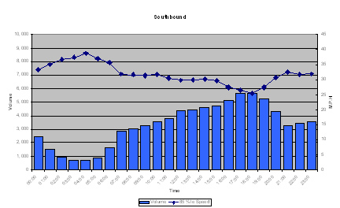
This was taken from the
Report considering the benefits and feasibility of implementing a 20mph speed limit on London’s Bridges (Thames Crossings) /
by
Road Safety Engineering London Road Safety Unit Road Network Performance
TfL Street Management / December 2008
See APPENDIX 2

3] Impact forces at various vehicle speeds and road conditions

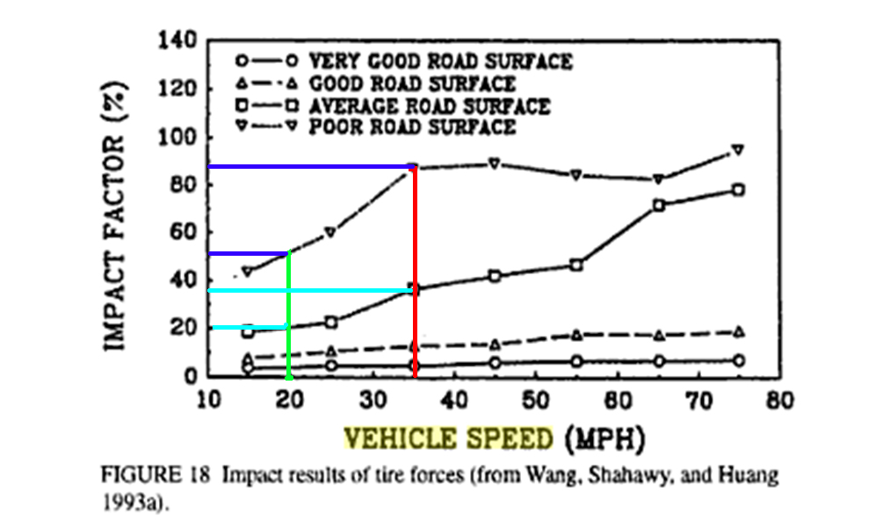

This diagram is taken from a book Dynamic impact factors for bridges, pp21,22,, By David I. McLean, M. Lee Marsh, I have added the coloured lines.
See APPENDIX 3

It shows the relative impact force on the road surface of vehicles moving at various speeds

If we compare the impact factor at 20mph [green line] to 35 mph [red line], the diagram shows that for

an average road surface the impact factor rises from 20 to 36 units [turquoise lines]. Ie a by a ratio of 1.8

and for a poor road surface the impact factor rises from 51 to 87 units [navy blue lines]. Ie a ratio of 1.7

if we compare 20mph to 30mph, [30mph line not drawn on map]

an average road surface the impact factor rises from 20 [turquoise line].to 30 units Ie a by a ratio of 1.5

and for a poor road surface the impact factor rises from 51 [navy blue line] to 76 units. Ie a ratio of 1.5

So if there was 20mph limit and it was policed with an average speed camera so that very few vehicles went above 20mph, it would have a significant effect on the damaging forces transmitted to the bridge.

The condition of the road surface is of great significance, and once the surface starts breaking up the damaging forces become much greater. So following the green line, as the condition deteriorates from good, to average, to poor the ratio of the impact force rises from 10 to 20 to 51, ie becomes 2x and 5x greater respectively.

Not only would there be benefit from a 20mph limit, but the road surface should be of high quality and repaired as soon as it starts breaking up.

4] TOWER BRIDGE

Tower Bridge has a 20mph limit to reduce the vibration damage to its structure.

The article “Tower Bridge speeders offered lessons in safety” /11th January 2008
[ http://www.drivetech.co.uk/press_releases_080111.html ] Includes

“The workshop also explains why the 20mph limit is in place at Tower Bridge, and the damage that vibrations caused by faster vehicles cause to this national landmark.”

Tower Bridge is similar in many ways to Hammersmith Bridge, with its deck being supported by a steel framework, Hammersmith Bridge by wrought iron.

A document supporting the planning application for a 20mph limit on Tower Bridge discusses suitable equipment for measuring speed on a listed building,
See TowerBridge20mphPlanningDoc.pdf – attached
Or http://tinyurl.com/26yeon5

5] THE PRESENT STATE OF HAMMERSMITH BRIDGE

The deck is breaking up. The seals between panels of the deck are broken. Salt put on the road is getting through to the structure supporting the surface. The very poor surface means that the vibrational forces transmitted to the bridge from the tyres is high.

It appears that vibrational damage to the surface is significant. The impact forces may also be damaging the supporting structure as with Tower Bridge.

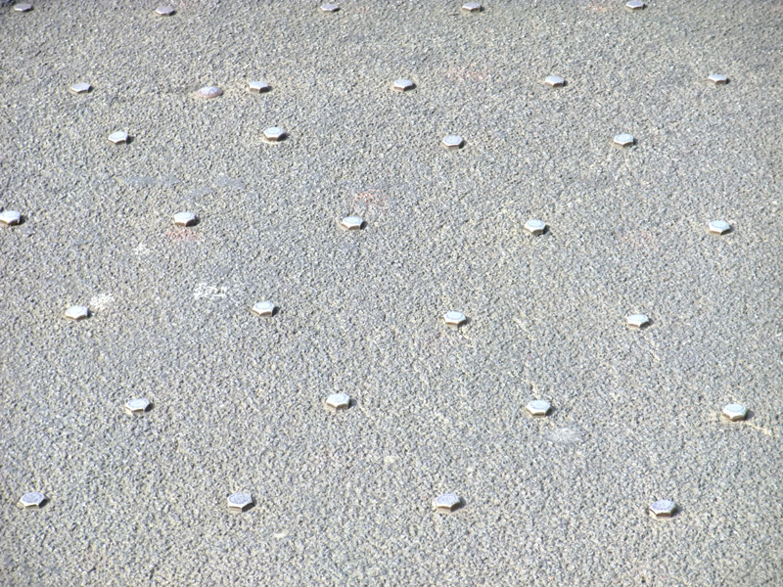

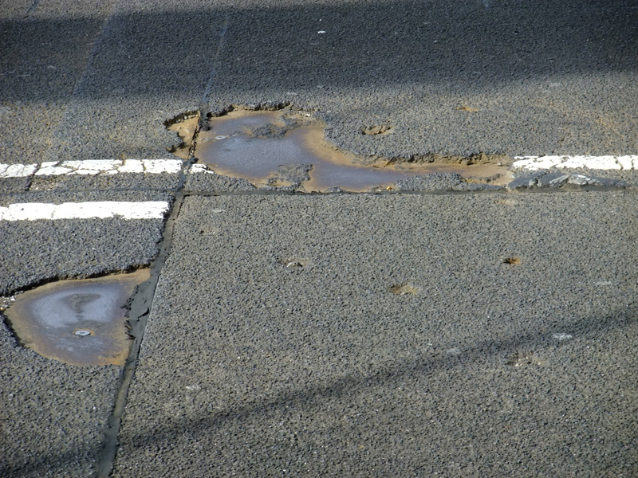

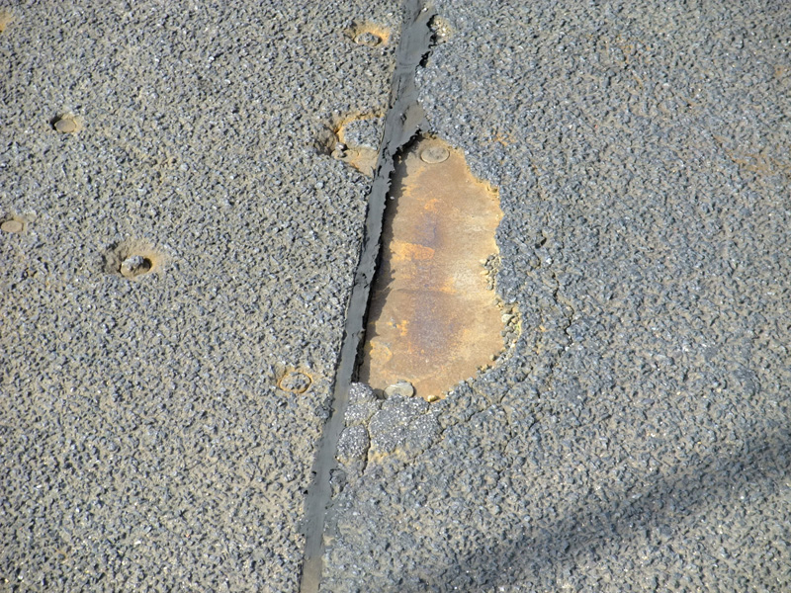

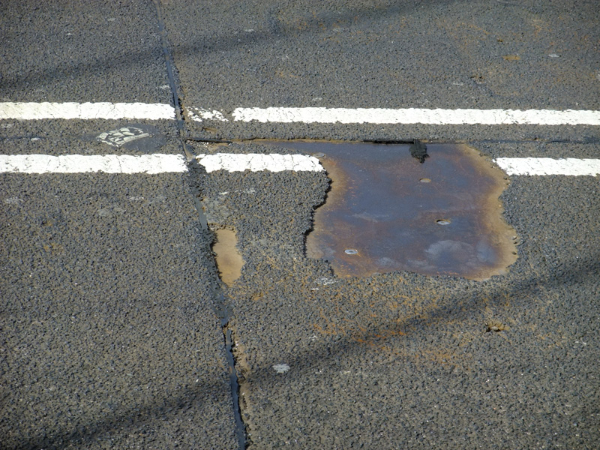
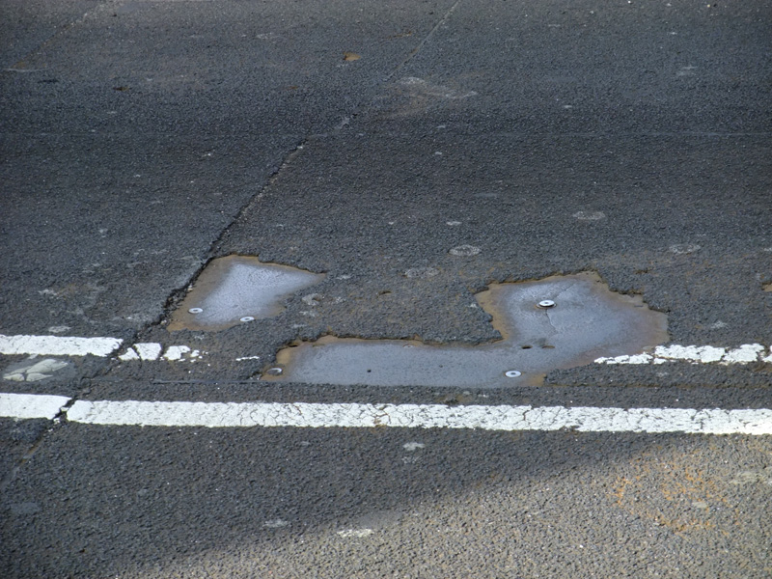

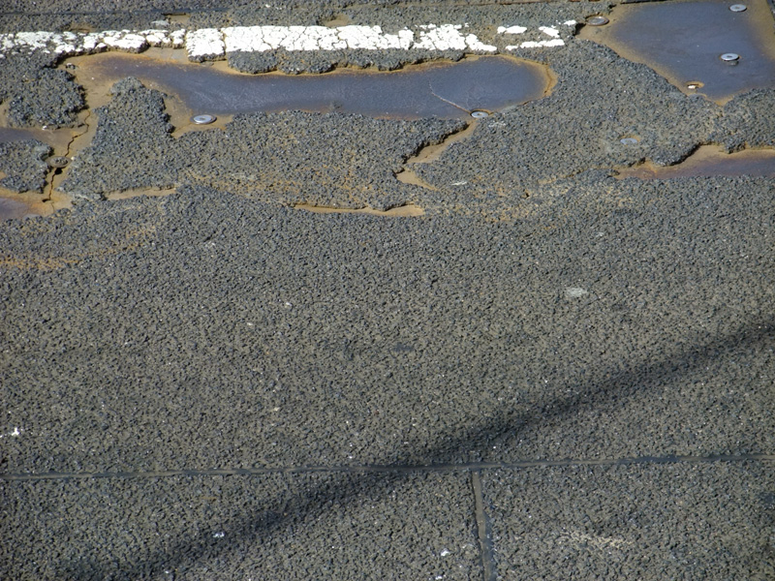

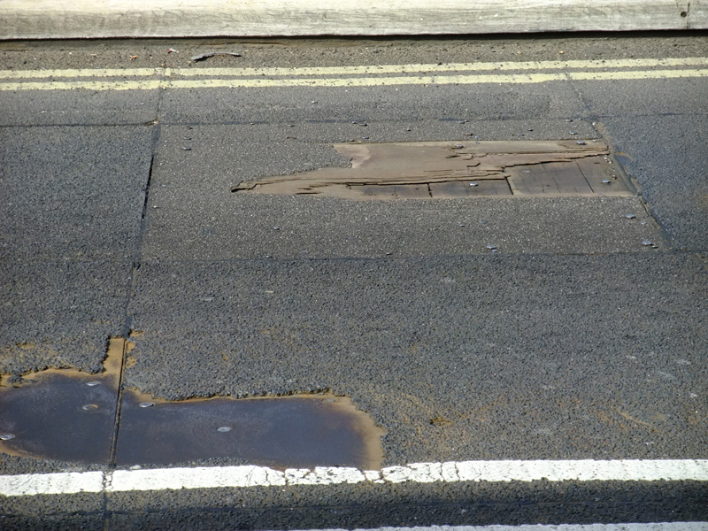

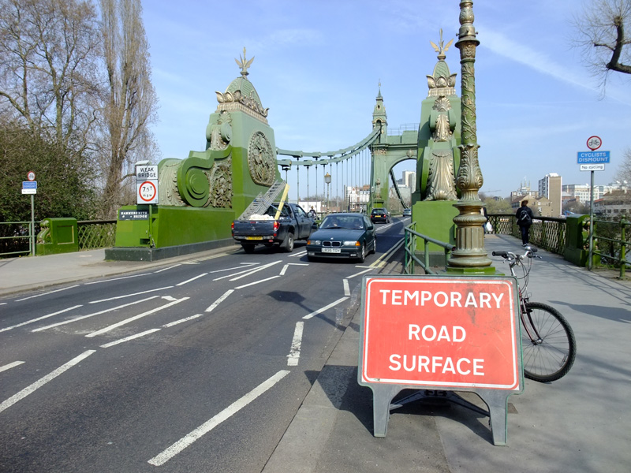

6] CONCLUSION

I would suggest instigating a 20mph limit as soon as possible, both on the grounds of improving the amenity of the river crossing for cyclists and pedestrians, and also on the grounds of preserving the heritage of Hammersmith and savings on future engineering costs..

John Griffiths
Chair hfcyclists
122c Edith rd
West Kensington
W14 9AP
020 7371 1290 / 07789 095 748

25 March 2011

ATTACHMENTS:

20mphOnhammersmithBridge.doc

TowerBridge20mphPlanningDoc.pdf

APPENDIX 1

From: "Alizadeh Anvar" <anvar.alizadeh@lbhf.gov.uk>
To: <truefeelings@btinternet.com>
Sent: Friday, February 04, 2011 2:46 PM
Subject: Hammersmith Bridge - proposal for 20mph speed limit

Dear Mr Griffiths,
Having looked at the technical documents that you forwarded to Chris Bainbridge re the above, I note that even though the research was done on the standard bridges (i.e. simple or continuous span structures and not on suspension bridges like Hammersmith Bridge), the change in amplification factor is insignificant from 30mph to 20mph on good surfacing conditions with a small reduction in the amplification factor on an average surfacing conditions (see Figure 18 on the tech. docs). As mentioned, Hammersmith bridge is a suspension bridge with a unique system of integrated surfacing panels and the load transfer to various members and the bridge behaviour is quite different compared with standard bridges. The graph in figure 18 of the document is a generalised result of studies carried out on typical bridges with solid decks topped with conventional surfacing. I also note that the literature suggests that further research into behaviour of cable stayed bridges (which are similar but not exactly the same as suspension bridges) needs still to be done to establish if any speed reduction equates to any reduction in amplification factors on these structures. I do not think reduction of speed from 30mph to 20mph on Hammersmith Bridge will significantly change load distribution to members and as such will not benefit the structural durability/capacity of the bridge.
In any case, I understand that a speed survey over the bridge was done in 2008 by TFL which indicated the average speed over the bridge was 25mph. I suspect due to the constraints (width restrictions/Barriers) on either approach of the bridge, together with the bumper to bumper traffic flows during peak times, it would not be possible to reach speeds of 30mph in majority of circumstances.
I trust the above addresses your query.
Regards
Anvar Alizadeh
Anvar Alizadeh
Capital Projects Manager
Highways & Engineering Services
e-mail: anvar.alizadeh@lbhf.gov.uk<mailto:anvar.alizadeh@lbhf.gov.uk>
tel: 020-8753 3033
fax: 020-8753 2208
APPENDIX 2 Hammersmith Bridge data
Graphs showing the traffic volume and 85%ile speed by hour of day.

APPENDIX 3

http://tinyurl.com/32gnamv

pp21,22, Dynamic impact factors for bridges
By David I. McLean, M. Lee Marsh,

