Section PLAN

From Westfield’s Planning Application for the Southern Interchange

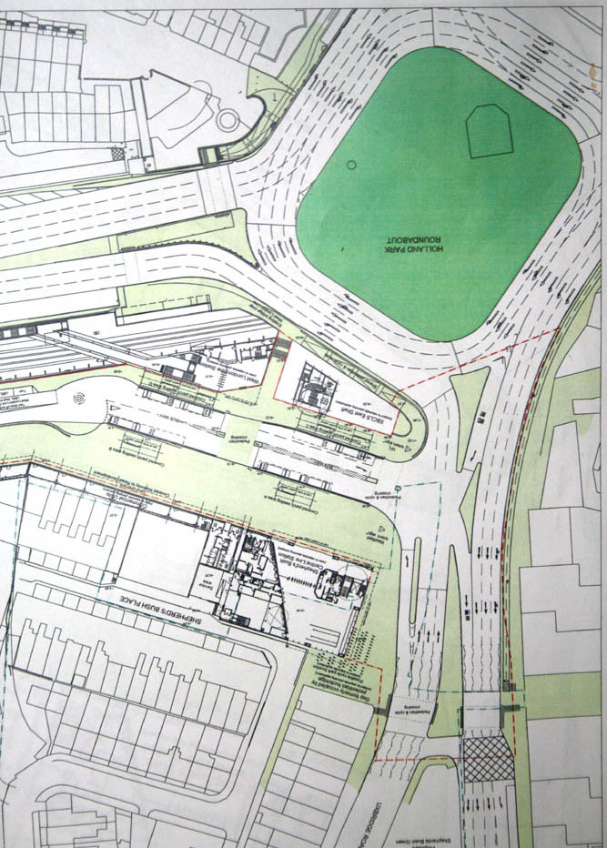

To see plans of Westfield’s application for the Southern Interchange, Go to www.apps.lbhf.gov.uk/PublicAccess/tdc/DcApplication/application_searchform.aspx
Put 2007/02266/FUL into the Application No box, and click SEARCH at the bottom,
CLICK “Click to view” / CLICK “Associated Documents” Tab
CLICK “View associated documents
Go to TRANSPORT STATEMENT - MAIN REPORT
CLICK “whole document” / go to page 17 of 18 to see the original pdf

