Note of site meeting with John Griffiths and Slobodan.Vuckovic,
Monday 25 June 2012, at 11.30am, and some post meeting observations

JG and SV met at the bus barrier. The object was to look the possibility of providing a link for cyclists coming over Hammersmith Bridge to the CSH9 going towards the Apollo. SV said that he believed that there would be no problem in TfL funding such work as a link to the CSH9.

We discussed a couple of suggestions that JG had sent to SV earlier.

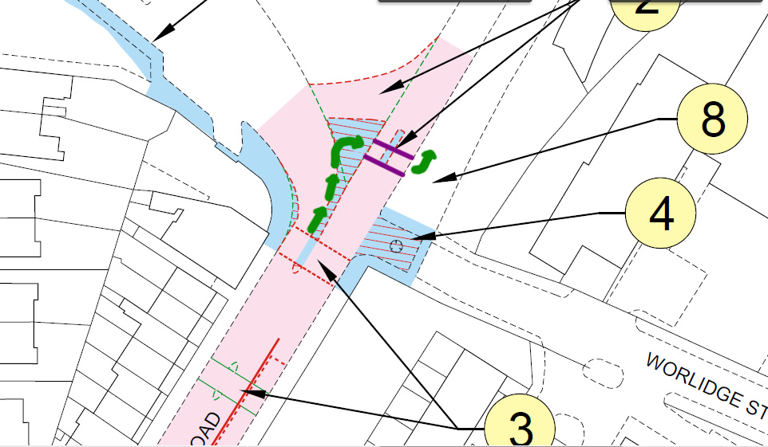

Suggestion 1 – Reservoir at bus-gate. This involved using the spare island near the bus gate as a reservoir for cyclists. An additional crossing for cyclists, ganged with the other crossing would allow cyclists to cross the southbound flow.

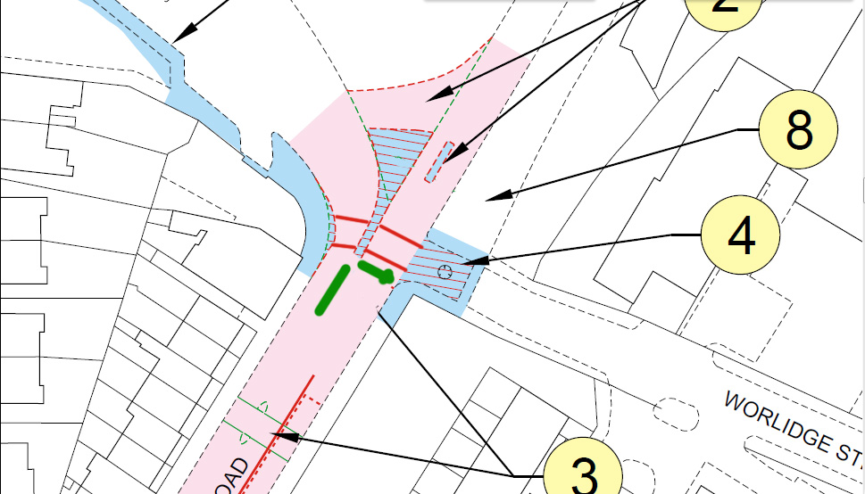

Suggestion 2 – Moving the Toucan to Worlidge street, and having a reservoir before the crossing in the centre of the road. From an urban design point of view, it would make sense to take some land from the housing estate to continue the wide footway towards the river. This would also allow space to widen the road if needed for a central refuge.

SV said that as both of these required cyclists to move to the right of the traffic flow, neither would be likely to pass a safety audit,

SV suggested cyclists should use Rutland Grove, up to the Bridge Avenue surface level crossing, use the A4 northern footway and join the CSH9 there. JG pointed out that this was perhaps too long a diversion.

Most cyclists appeared to do a manoeuvre that involved passing by or through the central island of the crossing.. One cyclist pulled up at the left hand kerb and used the crossing when the traffic had stopped. SV proposed a drop kerb to take cyclists of the road before the crossing.

There is construction going on obstructing the footway at this point. This is for a development “Oxford House – W6”. We assumed that the building would go up to the line of the fence, but not include a part that jutted out into the footway. We would try and find the plans.

Concerning Hammersmith Bridge, SV had no objections to a 20mph speed limit on it, and would endorse it. SV did not approve of cyclists logos on the carriageway of the bridge. JG thought they would be valuable to indicate to drivers that cyclists may be expected to use the full carriageway at the narrow points.

Observations by John Griffiths on Wednesday 27 June 2012 of the crossing, between 8.45am and 9am.

JG went there to see what conditions were like earlier in the day. At 8.45 am most of the cyclist traffic into town and pedestrian traffic to school was probably already over.

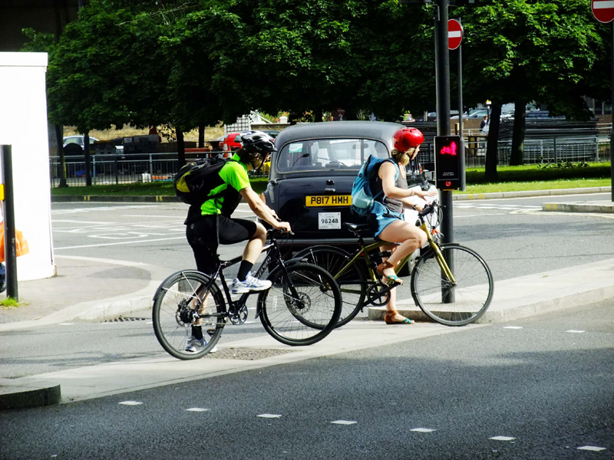

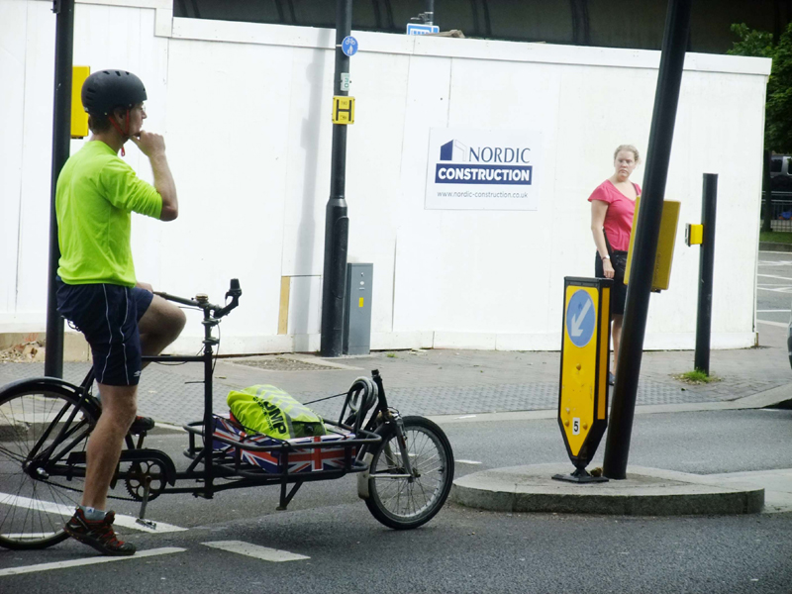

Most cyclists used the central refuge or the central area of the road as a reservoir before turning. Some shot straight across on a diagonal path if there was no oncoming traffic.

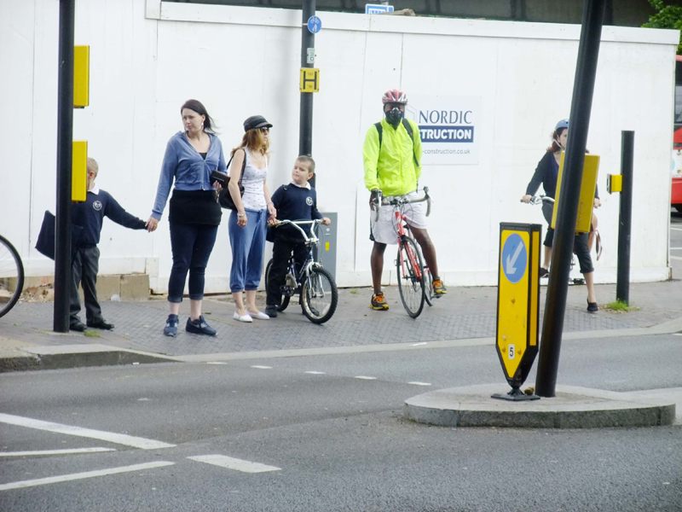

On the footpath occasionally there were a few people waiting.

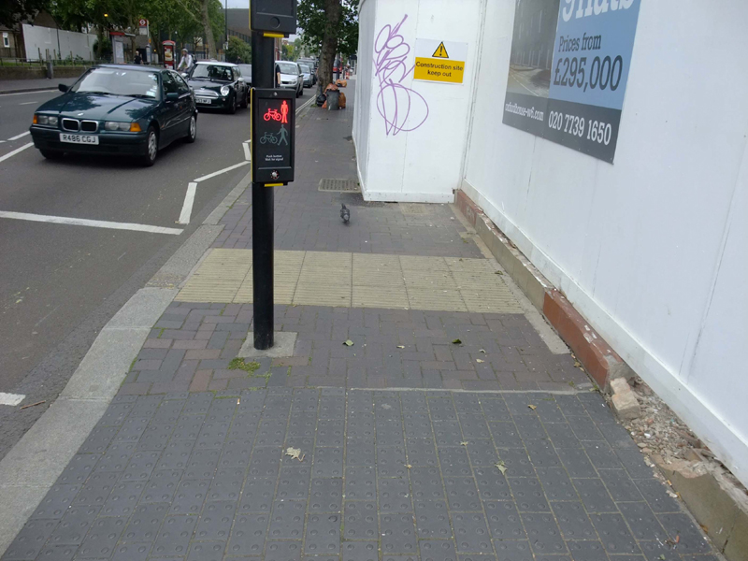

On the footpath there is not much space for cyclists to manoeuvre around the traffic signal. They then have to cross both arms of the crossing. The boundary of the new building, a fenced off yard /patio is presumably where the old red piece of concrete wall is. If the yellow blocks in the street are 400 x 400mm, the free space will be about 1.7m

Additional comments by John Griffiths, 27 June 2012

There are instances elsewhere in the borough of taking cyclists off the carriageway on the right-hand side - for example at the Wood Lane. Uxbridge road and Goldhawk road feed-ins to traffic islands at Shepherds Bush Green. So designs that take cyclists off on the right should not be discarded out of hand.

Proper observations should be made at peak times to see what the cyclist and pedestrian flows and behaviour are. The cyclist flows may increase when CSH9 is constructed. The design should be built with these figures and behaviours in mind.

Plans of the Oxford House development can be found as below. It seems as if the full area of the lot is used for an underground car-park, with a lift and turntable. At ground level the face of the building is set back a little from the boundary, with a fence at the boundary of the property.
http://www.oxfordhouse-w6.com/documents/Oxford-House-Hammersmith-Bridge-Road_IDM.pdf

John Griffiths
020 7371 1290 / 07789 095 748

