26 May 2011

London Borough of Hammersmith & Fulham
Environment Services Department
4th Floor, Town Hall Extension, King St, London W6 9JU
Tel: 020 8753 4236
Email: kylee.simpson@lbhf.gov.uk
Web: www.lbhf.gov.uk

Dear Sir / Madam

Re: Thames Path – Dove Passage to Queen Caroline Street

Introduction
Currently the situation in respect to cyclists using the above route is confusing. We have also received complaints about cyclists travelling too fast particularly in the narrow section of the Thames Path either side of Hammersmith Bridge. It is proposed to implement measures to provide more clarity on cycle usage and encourage cyclists to use local streets to avoid the narrowest stretch of the Thames Path.

Present situation
There are many cyclists that use this stretch of the Thames Path as a safer alternative to the busy strategic roads that go through this area. It is also well used by pedestrians. Congregation of people around the two public houses in the Lower Mall does also create narrow pinch-points.

There are a few old "no cycling" and "cyclist dismount" signs along this section of the Thames Path. These are not generally adhered to and may not be legally supported.

The Parks Police have recently been taking enforcement action against speeding cyclists and have also put up enforcement type notices along the Thames Path at this point.

Legal jurisdiction
This section of Thames Path is covered by three different areas of legislation - highways, Open Space and a special Act of Parliament relating specifically to the Upper Mall and small areas of the Lower Mall.

Proposal
We propose to extend the successful shared pedestrian/cycling strategy that was implemented last year in the Upper Mall Open Space. This included using shared use paviours (shown below), introducing a cycling code of conduct and minor engineering works to improve the area for both.

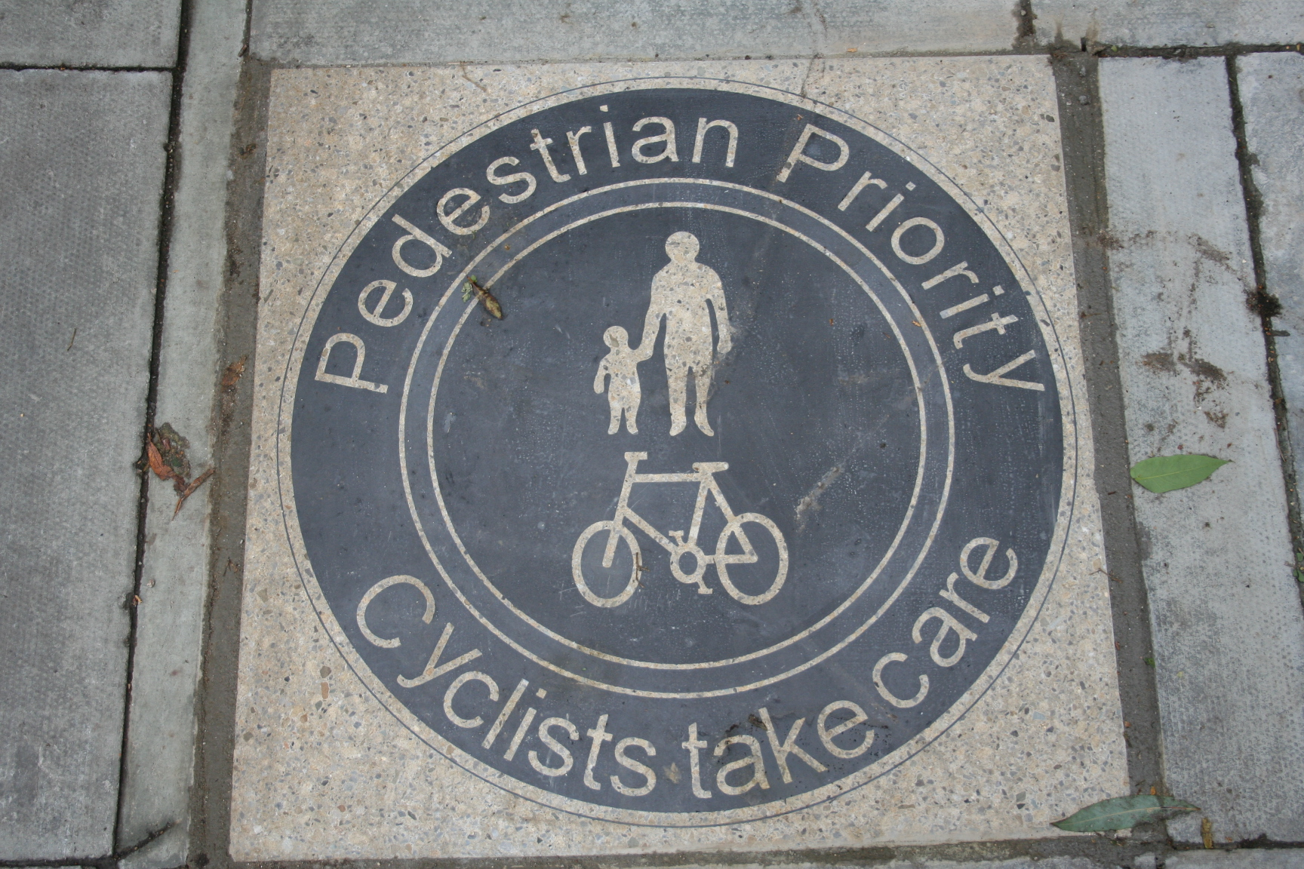

A plan is provided overleaf showing the proposed details. These include the use of paviours (as above) and the signing of a preferred alternative route for cyclists from just west of Hammersmith Bridge via Bridgeview Ave, Rutland Grove and onto the middle path through Furnival Gardens. These use local low trafficked roads so are likely to be safe for cyclists. It is recognised that some cyclists will wish to keep to the route along the Thames but it is hoped that the proposals will at least divert a significant number of cyclists from the narrow part of Lower Mall.

Cyclist dismount signs are still proposed for Dove Passage, albeit with the removal of any "no cycling" signage, here, and elsewhere along this stretch of the Thames Path.

If you have any comments please do not hesitate to contact me by using the above contact details. Please could you let me have any comments by Thursday the 16th of June.

Yours faithfully,

Kylee Simpson
Project Engineer

