Surface level crossings

A new Southern Plaza for Hammersmith

The Talgarth rd / A4 presents a barrier between the Broadway Centre and the area to the south, including the Apollo, Riverside Studios, the river, the hospital and offices along the riverside.

To cross the A4 you have to go down a subway. Soon new offices will be built along the river. To add to any congestion cyclists will soon be encouraged to wheel their bikes through the subway under the Fulham Palace rd.

Surface level crossings have been very successful on the north side of the gyratory. They are possible on the south side.

They could enhance the whole area, bringing the town centre back to the people.

Buses

There is news of a possible change to bus station operations. If in the future buses did not leave by the southern exit it would make surface level crossings far more satisfactory. It would have a great impact.

Planning decisions concerning bus operations should consider the effect upon future surface level crossings. The effects of alternative proposals on the whole gyratory should be considered.

Below are set out two options on how surface level crossings could be designed, The second option has no buses leaving the bus station by the southern exit. It is far superior.

John Griffiths
co-ordinator hfcyclists [London Cycling Campaign]
www.hfcyclists.org.uk
10 December 2002

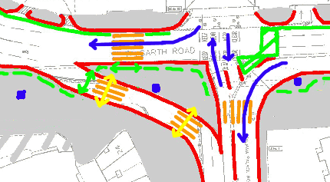 | A new Southern Plaza

Option 1
[with no changes to bus station]

The plan shows the intersection of Fulham Palace rd and Talgarth rd. At the moment traffic always flows past the southern entrance to the Broadway Centre.

It is essential to use an island to split the flows. This would allow pedestrians to cross from the Broadway Centre to the island, and from there to the Apollo or towards the Ark.

The present steps and ramps would have to be removed.

This is a slight revision of our earlier suggestion.

Traffic considerations

The pedestrian phases do not significantly reduce the traffic flows.

Buses flowing West out of the bus station are held at the pedestrian crossing until the next phase of the lights. There may be some problems here if the space into which buses would like to turn is blocked by other traffic.

The only timing that is considerably less than before is for the traffic turning South into Fulham Palace rd. At the moment it is on all the time unless buses are leaving the bus station going South. However the main bottleneck is where Fulham Palace rd narrows to one lane south of the junction.
Traffic Phases - [Option 1]

Phase 1  20 seconds  The Pedestrian and cycle crossings from the island to the Apollo and the Ark are open. Traffic flows in the Talgarth rd. | 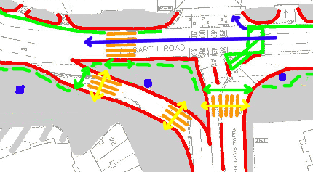
Phase 2  15 seconds  The Pedestrian and cycle crossings from the island to the Apollo are still open. Traffic continues to flow in the Talgarth rd. Traffic also flows South into the Fulham Palace rd. | 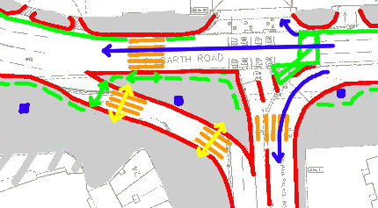
Phase 3  20 seconds  The Pedestrian crossing from the island to the Broadway Centre is open. Traffic flows as shown. Buses leave the Bus station going West but stop at the pedestrian crossing. | 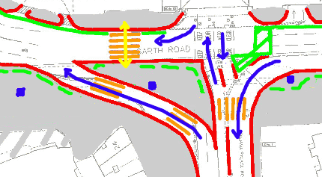
Phase 4

5 seconds

The Pedestrian crossing from the island to the Apollo is open. Traffic flows as shown. Buses leave the Bus station going West and clear the pedestrian crossing.

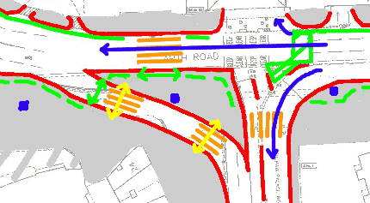 | A new Southern Plaza

Option 2
[with no buses leaving the bus station]

In this scenario the traffic flows are much simpler. It would be better for pedestrians, cyclists and cars [buses may not be so happy.]

The diagram still includes the space for buses to travel south from the bus station exit. [partly as the diagram was not redrawn, and if buses do travel south from the exit it is not as disruptive as buses turning right].

The streets could have a high quality treatment, like for example High Street Kensington, to raise the image of this area. It could also receive the kind of architectural input given to Lyric square.

I hope this stimulates discussion of various options before planning decisions are made.

Traffic considerations

The pedestrian phases do not significantly reduce the traffic flows. In fact if buses do not turn right traffic flows may be much better in all directions.

The only timing that is considerably less than before is for the traffic turning South into Fulham Palace rd. At the moment it is on all the time unless buses are leaving the bus station going South. However the main bottleneck is where Fulham Palace rd narrows to one lane south of the junction.
Traffic Phases - [Option 2]

Phase 1  20 seconds  The Pedestrian and cycle crossings from the island to the Apollo and the Ark are open. Traffic flows in the Talgarth rd. | 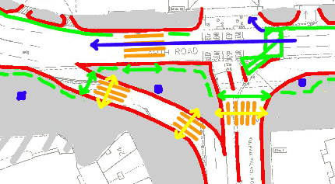
Phase 2

20 seconds

The Pedestrian and cycle crossings from the island to the Apollo are still open. Traffic continues to flow in the Talgarth rd. Traffic also flows South into the Fulham Palace rd.

Phase 3  20 seconds  The Pedestrian crossing from the island to the Broadway Centre is open. Traffic flows as shown. | 